# Hadoop Multi-Cluster Lab

**Mahnoor Adeel - 26913 | Zuha Aqib - 26106**

### Purpose

This lab sets up two independent Hadoop clusters for learning HDFS administration, YARN operations, and inter-cluster data transfer using *DistCp*

Note: DistCp (Distributed Copy) is a Hadoop tool used for large-scale data copying between HDFS clusters (or between HDFS and compatible file systems such as S3, Azure Blob, etc.). It’s designed to efficiently copy massive datasets in a parallel, fault-tolerant manner using MapReduce.

### Prerequisites

* Ubuntu host with Docker and Docker Compose installed
* At least 16 GB RAM available
* Ports 9870, 8088, 9970, 9088 should be free on your host

### Setup Instructions – First we will create Cluster 1 and then Cluster 2

#### Step 1: Create Lab Directory

* mkdir -p ~/hadoop-multicluster-lab
* cd ~/hadoop-multicluster-lab

#### Step 2: Create docker-compose-cluster1.yml

Save this file in ~/hadoop-multicluster-lab/docker-compose-cluster1.yml:

* version: "3.8"
* services:
* namenode-c1:
* image: bde2020/hadoop-namenode:2.0.0-hadoop3.2.1-java8
* container_name: namenode-c1
* hostname: namenode-c1
* ports:
* - "9870:9870"
* - "8020:8020"
* volumes:
* - ./cluster1-data/namenode:/hadoop/dfs/name
* environment:
* - CLUSTER_NAME=hadoop-cluster-1
* - CORE_CONF_fs_defaultFS=hdfs://namenode-c1:8020
* networks:
* - cluster1-net
* - shared-net
* restart: unless-stopped
* datanode1-c1:
* image: bde2020/hadoop-datanode:2.0.0-hadoop3.2.1-java8
* container_name: datanode1-c1
* hostname: datanode1-c1
* depends_on:
* - namenode-c1
* ports:
* - "9864:9864"
* volumes:
* - ./cluster1-data/datanode1:/hadoop/dfs/data
* environment:
* - CORE_CONF_fs_defaultFS=hdfs://namenode-c1:8020
* networks:
* - cluster1-net
* - shared-net
* restart: unless-stopped
* datanode2-c1:
* image: bde2020/hadoop-datanode:2.0.0-hadoop3.2.1-java8
* container_name: datanode2-c1
* hostname: datanode2-c1
* depends_on:
* - namenode-c1
* ports:
* - "9865:9864"
* volumes:
* - ./cluster1-data/datanode2:/hadoop/dfs/data
* environment:
* - CORE_CONF_fs_defaultFS=hdfs://namenode-c1:8020
* networks:
* - cluster1-net
* - shared-net
* restart: unless-stopped
* datanode3-c1:
* image: bde2020/hadoop-datanode:2.0.0-hadoop3.2.1-java8
* container_name: datanode3-c1
* hostname: datanode3-c1
* depends_on:
* - namenode-c1
* ports:
* - "9866:9864"
* volumes:
* - ./cluster1-data/datanode3:/hadoop/dfs/data
* environment:
* - CORE_CONF_fs_defaultFS=hdfs://namenode-c1:8020
* networks:
* - cluster1-net
* - shared-net
* restart: unless-stopped
* resourcemanager-c1:
* image: bde2020/hadoop-resourcemanager:2.0.0-hadoop3.2.1-java8
* container_name: resourcemanager-c1
* hostname: resourcemanager-c1
* ports:
* - "8088:8088"
* depends_on:
* - namenode-c1
* environment:
* - CORE_CONF_fs_defaultFS=hdfs://namenode-c1:8020
* - YARN_CONF_yarn_resourcemanager_hostname=resourcemanager-c1
* networks:
* - cluster1-net
* - shared-net
* restart: unless-stopped
* nodemanager1-c1:
* image: bde2020/hadoop-nodemanager:2.0.0-hadoop3.2.1-java8
* container_name: nodemanager1-c1
* hostname: nodemanager1-c1
* depends_on:
* - resourcemanager-c1
* ports:
* - "8042:8042"
* environment:
* - CORE_CONF_fs_defaultFS=hdfs://namenode-c1:8020
* - YARN_CONF_yarn_resourcemanager_hostname=resourcemanager-c1
* - YARN_CONF_yarn_nodemanager_aux___services=mapreduce_shuffle
* - YARN_CONF_yarn_nodemanager_resource_memory___mb=2048
* - YARN_CONF_yarn_nodemanager_resource_cpu___vcores=2
* networks:
* - cluster1-net
* - shared-net
* restart: unless-stopped
* nodemanager2-c1:
* image: bde2020/hadoop-nodemanager:2.0.0-hadoop3.2.1-java8
* container_name: nodemanager2-c1
* hostname: nodemanager2-c1
* depends_on:
* - resourcemanager-c1
* ports:
* - "8043:8042"
* environment:
* - CORE_CONF_fs_defaultFS=hdfs://namenode-c1:8020
* - YARN_CONF_yarn_resourcemanager_hostname=resourcemanager-c1
* - YARN_CONF_yarn_nodemanager_aux___services=mapreduce_shuffle
* - YARN_CONF_yarn_nodemanager_resource_memory___mb=2048
* - YARN_CONF_yarn_nodemanager_resource_cpu___vcores=2
* networks:
* - cluster1-net
* - shared-net
* restart: unless-stopped
* networks:
* cluster1-net:
* driver: bridge
* shared-net:
* external: true

Task: Summarize the contents of this file in a few sentences

*The compose file defines a single-cluster Hadoop setup. It launches namenode, datanodes, resourcemanager, and nodemanagers. All the containers belong to Hadoop Cluster 1.They are connected through two Docker networks — cluster1-net, for in-cluster communication, and shared-net, for communication with other clusters.*

* *The Namenode runs the image bde2020/hadoop-namenode:2.0.0-hadoop3.2.1-java8 and exposes ports 9870 for the HDFS web UI and 8020 for HDFS RPC communication.*
* *The Datanodes the image bde2020/hadoop-datanode:2.0.0-hadoop3.2.1-java8 and expose ports 9864, 9865, and 9866 respectively on the host.*
* *The ResourceManager, running the image bde2020/hadoop-resourcemanager:2.0.0-hadoop3.2.1-java8, is accessible on port 8088, providing the YARN web interface.*
* *The NodeManagers use the image bde2020/hadoop-nodemanager:2.0.0-hadoop3.2.1-java8 and expose ports 8042 and 8043 respectively for their monitoring UIs.*

#### Step 3: Create docker-compose-cluster2.yml

Save this file in ~/hadoop-multicluster-lab/docker-compose-cluster2.yml:

* version: "3.8"
* services:
* namenode-c2:
* image: bde2020/hadoop-namenode:2.0.0-hadoop3.2.1-java8
* container_name: namenode-c2
* hostname: namenode-c2
* ports:
* - "9970:9870"
* - "8021:8020"
* volumes:
* - ./cluster2-data/namenode:/hadoop/dfs/name
* environment:
* - CLUSTER_NAME=hadoop-cluster-2
* - CORE_CONF_fs_defaultFS=hdfs://namenode-c2:8020
* networks:
* - cluster2-net
* - shared-net
* restart: unless-stopped
* datanode1-c2:
* image: bde2020/hadoop-datanode:2.0.0-hadoop3.2.1-java8
* container_name: datanode1-c2
* hostname: datanode1-c2
* depends_on:
* - namenode-c2
* ports:
* - "9964:9864"
* volumes:
* - ./cluster2-data/datanode1:/hadoop/dfs/data
* environment:
* - CORE_CONF_fs_defaultFS=hdfs://namenode-c2:8020
* networks:
* - cluster2-net
* - shared-net
* restart: unless-stopped
* datanode2-c2:
* image: bde2020/hadoop-datanode:2.0.0-hadoop3.2.1-java8
* container_name: datanode2-c2
* hostname: datanode2-c2
* depends_on:
* - namenode-c2
* ports:
* - "9965:9864"
* volumes:
* - ./cluster2-data/datanode2:/hadoop/dfs/data
* environment:
* - CORE_CONF_fs_defaultFS=hdfs://namenode-c2:8020
* networks:
* - cluster2-net
* - shared-net
* restart: unless-stopped
* datanode3-c2:
* image: bde2020/hadoop-datanode:2.0.0-hadoop3.2.1-java8
* container_name: datanode3-c2
* hostname: datanode3-c2
* depends_on:
* - namenode-c2
* ports:
* - "9966:9864"
* volumes:
* - ./cluster2-data/datanode3:/hadoop/dfs/data
* environment:
* - CORE_CONF_fs_defaultFS=hdfs://namenode-c2:8020
* networks:
* - cluster2-net
* - shared-net
* restart: unless-stopped
* resourcemanager-c2:
* image: bde2020/hadoop-resourcemanager:2.0.0-hadoop3.2.1-java8
* container_name: resourcemanager-c2
* hostname: resourcemanager-c2
* ports:
* - "9088:8088"
* depends_on:
* - namenode-c2
* environment:
* - CORE_CONF_fs_defaultFS=hdfs://namenode-c2:8020
* - YARN_CONF_yarn_resourcemanager_hostname=resourcemanager-c2
* networks:
* - cluster2-net
* - shared-net
* restart: unless-stopped
* nodemanager1-c2:
* image: bde2020/hadoop-nodemanager:2.0.0-hadoop3.2.1-java8
* container_name: nodemanager1-c2
* hostname: nodemanager1-c2
* depends_on:
* - resourcemanager-c2
* ports:
* - "8142:8042"
* environment:
* - CORE_CONF_fs_defaultFS=hdfs://namenode-c2:8020
* - YARN_CONF_yarn_resourcemanager_hostname=resourcemanager-c2
* - YARN_CONF_yarn_nodemanager_aux___services=mapreduce_shuffle
* - YARN_CONF_yarn_nodemanager_resource_memory___mb=2048
* - YARN_CONF_yarn_nodemanager_resource_cpu___vcores=2
* networks:
* - cluster2-net
* - shared-net
* restart: unless-stopped
* nodemanager2-c2:
* image: bde2020/hadoop-nodemanager:2.0.0-hadoop3.2.1-java8
* container_name: nodemanager2-c2
* hostname: nodemanager2-c2
* depends_on:
* - resourcemanager-c2
* ports:
* - "8143:8042"
* environment:
* - CORE_CONF_fs_defaultFS=hdfs://namenode-c2:8020
* - YARN_CONF_yarn_resourcemanager_hostname=resourcemanager-c2
* - YARN_CONF_yarn_nodemanager_aux___services=mapreduce_shuffle
* - YARN_CONF_yarn_nodemanager_resource_memory___mb=2048
* - YARN_CONF_yarn_nodemanager_resource_cpu___vcores=2
* networks:
* - cluster2-net
* - shared-net
* restart: unless-stopped
* networks:
* cluster2-net:
* driver: bridge
* shared-net:
* external: true

#### Task: Summarize the contents of this file in a few sentences

*All the containers in this setup belong to Hadoop Cluster 2. They are connected through two networks, cluster2-net, for internal cluster communication, and shared-net for communication with other clusters.*

*Cluster 2 is almost identical to Cluster 1 in setup and configuration, except that it uses different port mappings to avoid conflicts when both clusters run simultaneously.*

#### Step 4: Create Shared Network

* docker network create shared-net

#### Step 5: Start Cluster 1

* cd ~/hadoop-multicluster-lab
* docker compose -f docker-compose-cluster1.yml up -d
* sleep 15
* docker ps --filter "name=c1"

Task: Why the sleep 15 command?

*This gives Cluster 1 containers enough time to start up and initialize properly. Otherwise, Docker might still be initializing containers, and docker ps command could show incomplete or missing results.*

Task:Take a screenshot showing all Cluster 1 containers running

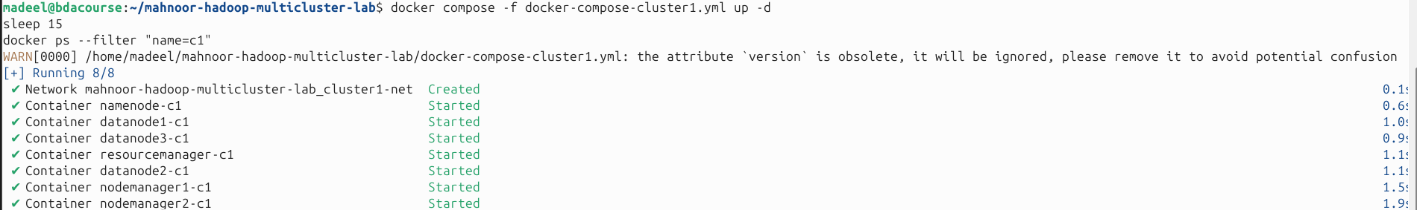

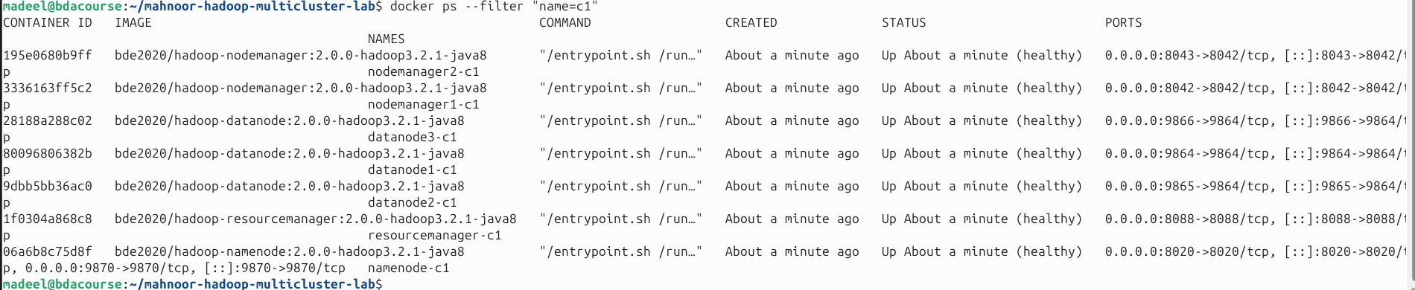

#### Step 6: Start Cluster 2

* docker compose -f docker-compose-cluster2.yml up -d
* sleep 15
* docker ps --filter "name=c2"

Task: Take a screenshot showing all Cluster 2 containers running

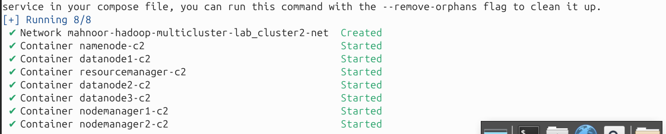

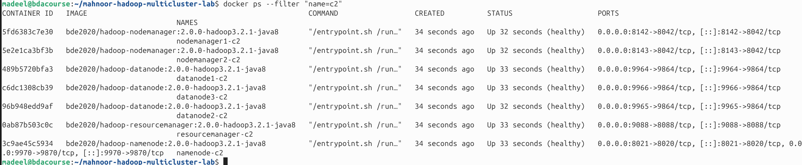

#### Step 7: Verify Network Connectivity

* docker exec namenode-c1 ping -c 3 namenode-c2
* docker exec namenode-c2 ping -c 3 namenode-c1

Task: Screenshot showing successful ping between clusters – also explain the outputs.

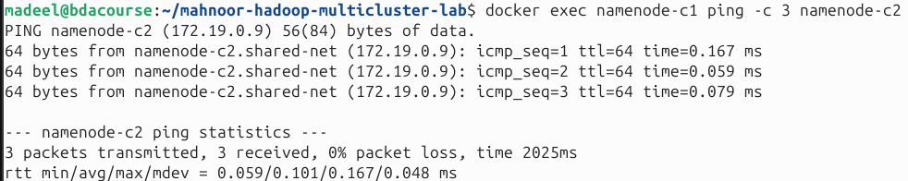

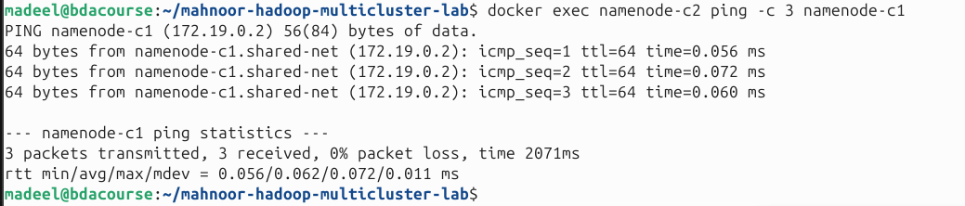

*********************************

## Web UI Access

#### Cluster 1 UIs:

* **NameNode**: <http://localhost:9870>
* **ResourceManager**: <http://localhost:8088>
* **DataNode 1**: <http://localhost:9864>

#### Cluster 2 UIs:

* **NameNode**: <http://localhost:9970>
* **ResourceManager**: <http://localhost:9088>
* **DataNode 1**: <http://localhost:9964>

Task: Open both NameNode UIs side-by-side showing the cluster overview. Explain the outputs. 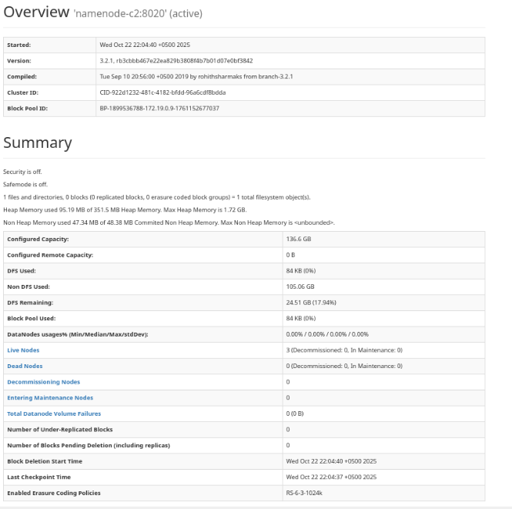

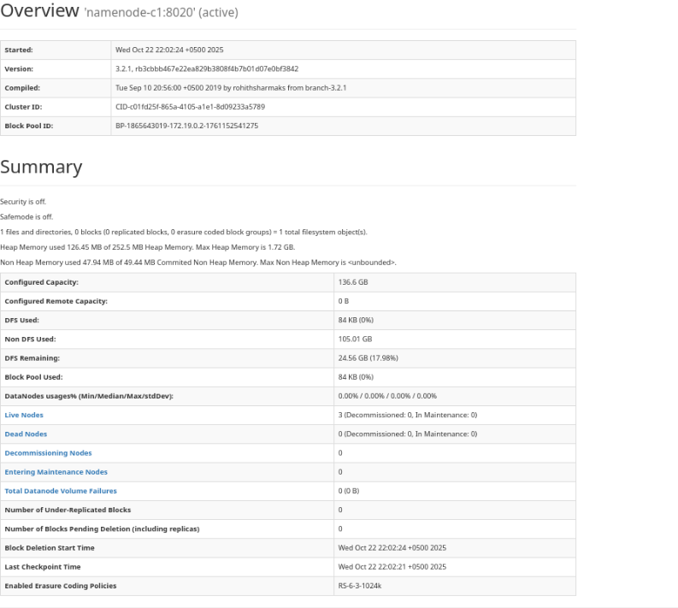

## Lab Exercises

#### Exercise 1: Create and Upload Your Own Dataset to Cluster 1

**Task**: Create a custom dataset file on your local machine, then upload it to HDFS on Cluster 1. Show proof of transfer and give some description about this dataset (it must be a big dataset or from amongst the data sources I uploaded).

**What to do**:

1. Create a text file with at least 20 lines of data (use any text editor or echo commands)
2. Upload this file to HDFS under /user/yourname/dataset/
3. Verify the upload was successful by listing the directory
4. Display the contents of your uploaded file

Task: Screenshot of the terminal output of your file listing and content display commands (***Hint****: You'll need to use hdfs dfs -mkdir, hdfs dfs -put, hdfs dfs -ls, and hdfs dfs -cat*)



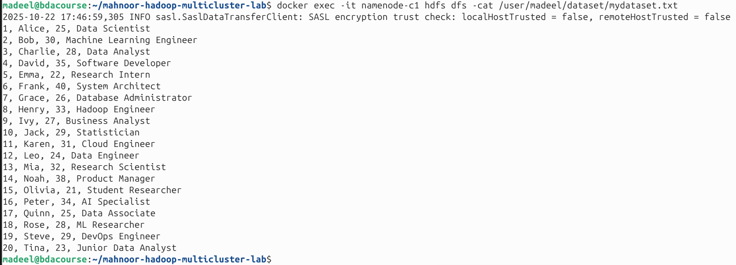

#### Exercise 2: Check File Replication and Block Distribution

**Task**: Examine how your uploaded file is replicated across DataNodes.

**What to do**:

1. Use HDFS commands to get detailed information about your file (replication factor, block size)
2. Check which DataNodes are storing copies of your file
3. Take note of the block IDs and their locations

Screenshot of the output displaying file status and block locations



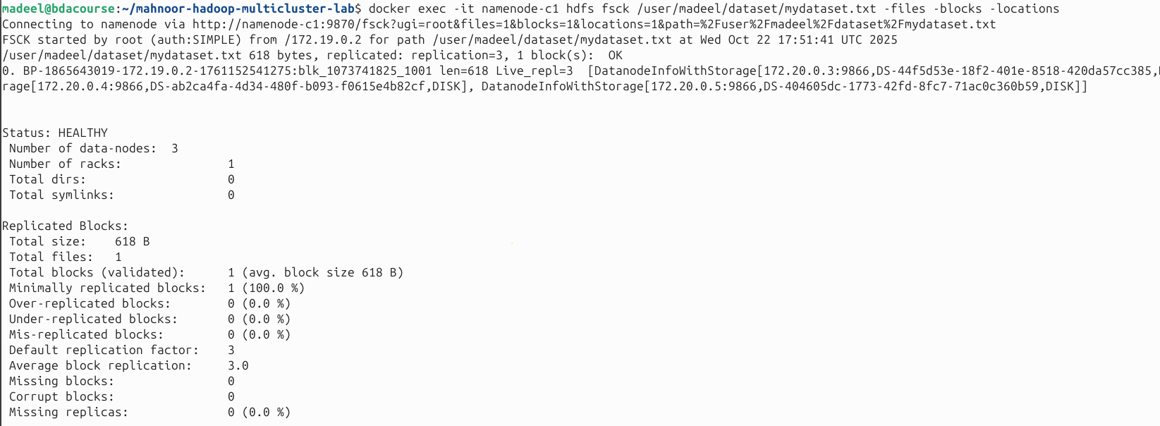

**Then verify in UI**: Open http://localhost:9870, browse to your file, and compare what you see in the UI with the command output (***Hint****: Use hdfs fsck /user/yourname/dataset/yourfile -files -blocks -locations)*

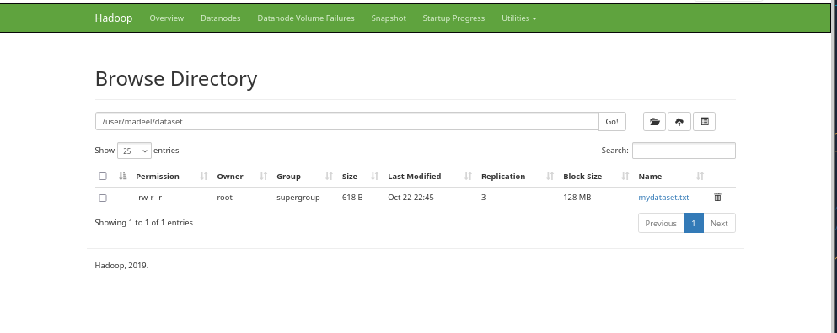

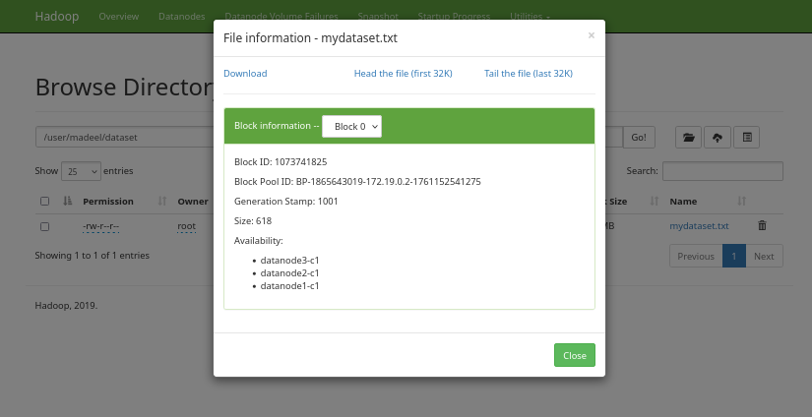

*Both the command-line output and the HDFS web UI show consistent information about the file, including its size, replication factor, and the DataNodes storing each block. The web UI shows in a more easy-to-read format.*

#### Exercise 3: Test Fault Tolerance - DataNode Failure

**Task**: Stop one DataNode and observe how the cluster maintains data availability.

**What to do**:

1. Check current cluster status (number of live nodes)
2. Stop datanode2-c1
3. Wait 30 seconds, then check cluster status again
4. Try to read your file - it should still be accessible!
5. Check which DataNodes are now serving the file
6. Restart the DataNode and verify it rejoins the cluster

Task: Screenshot cluster status before DataNode failure (all 3 nodes live)

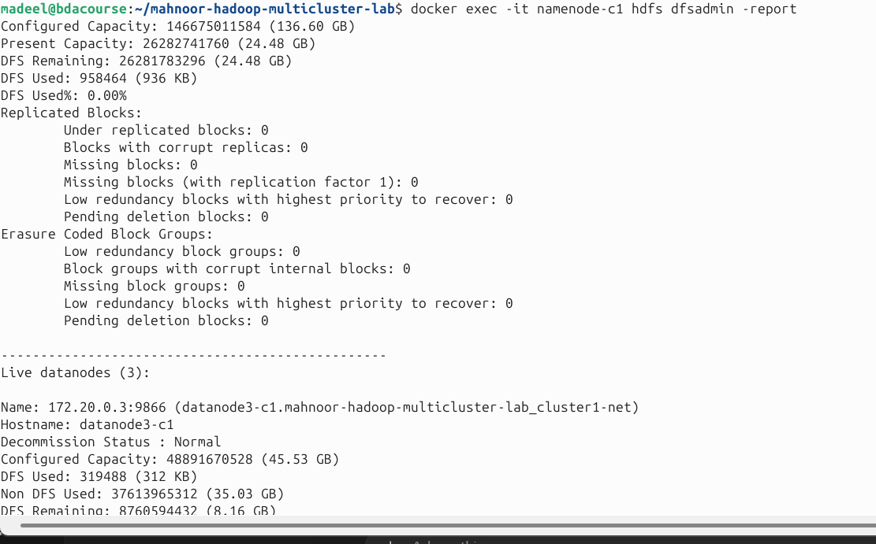

Task: Screenshot cluster status after failure (2 nodes live) and successful file read despite the failure

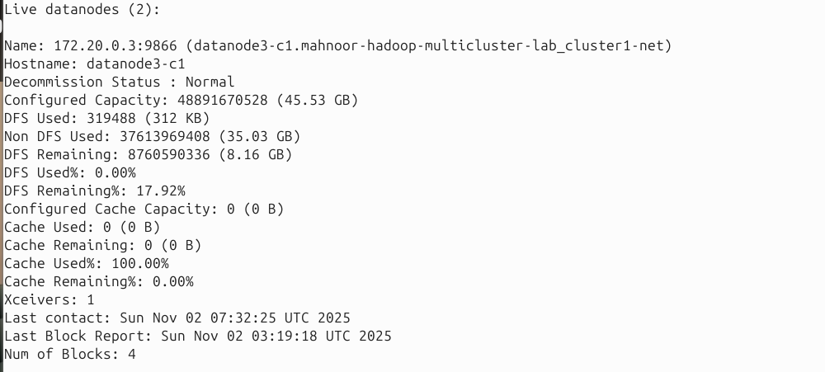

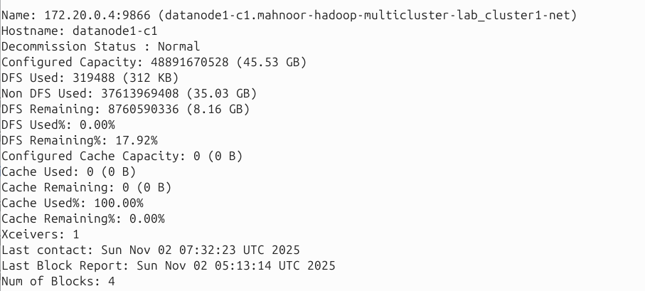

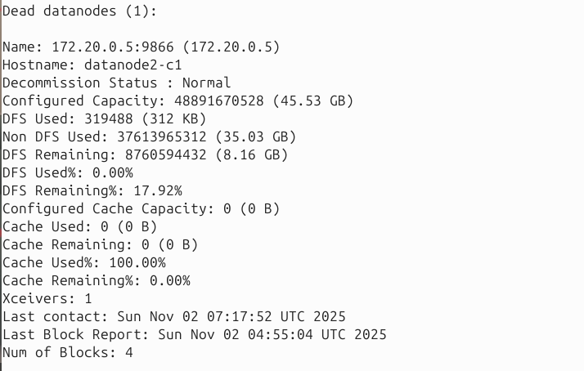

**File Still accessible:**

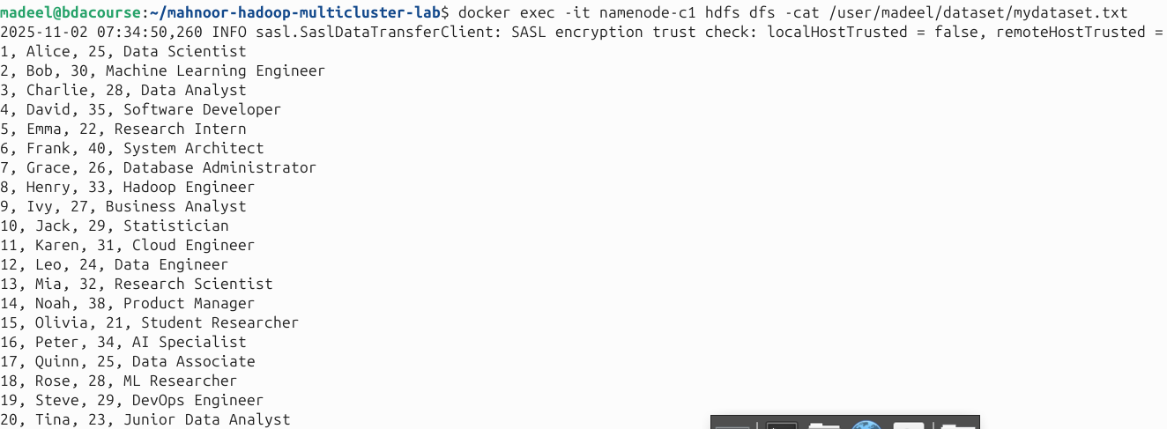

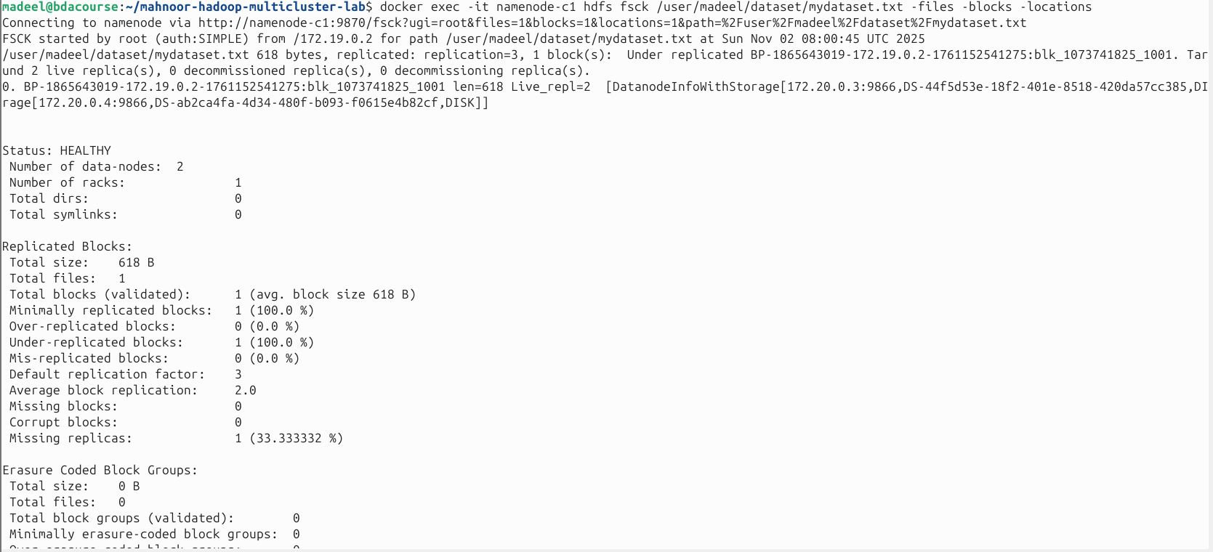

**Screenshot 4**: Screenshot of the cluster status (***Hint****: Use hdfs dfsadmin -report and docker stop/start datanode2-c1*)

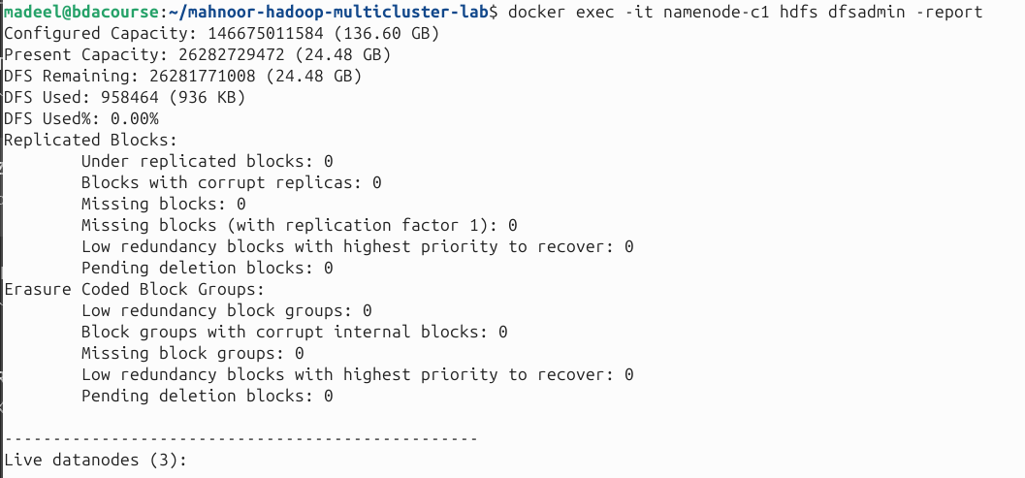

#### Exercise 4: Create Multiple Files with Different Sizes

**Task**: Create and upload files of different sizes to see how HDFS handles them.

**What to do**:

1. Create three files:
   * Small file: ~100 lines (~5KB)
   * Medium file: ~5000 lines (~250KB)
   * Large file: ~20000 lines (~1MB)
2. Upload all three to HDFS under /user/yourname/sizetest/
3. Check the block distribution for each file
4. Observe: How many blocks does each file have?

**Task:** Screenshot the fsck output for all three files, highlighting the number of blocks each file uses (**Hint**: Use a for loop to generate files: for i in {1..5000}; do echo "Line $i content"; done > medium.txt)

Then we generated SMALL MEDIUM LARGE text files

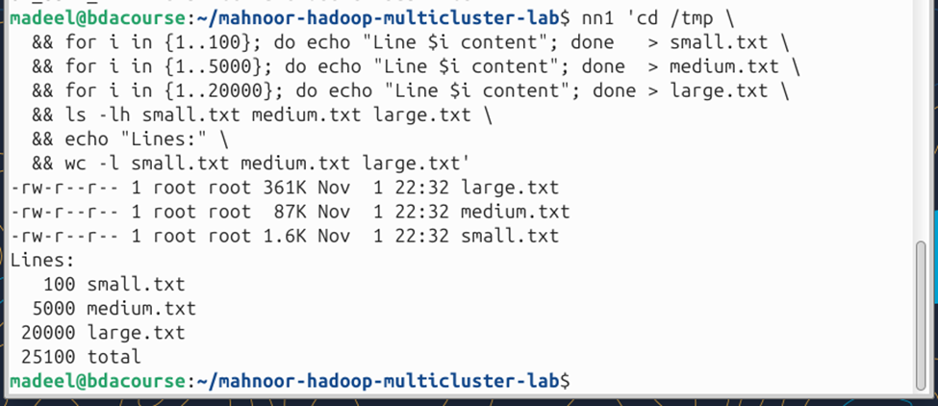

Then we uploaded on HDFS

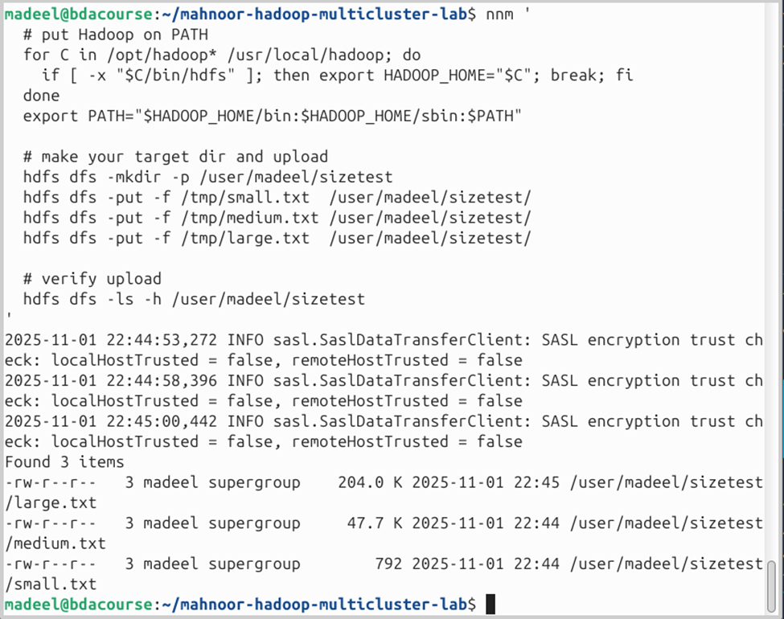

Then we observed block distribution for SMALL

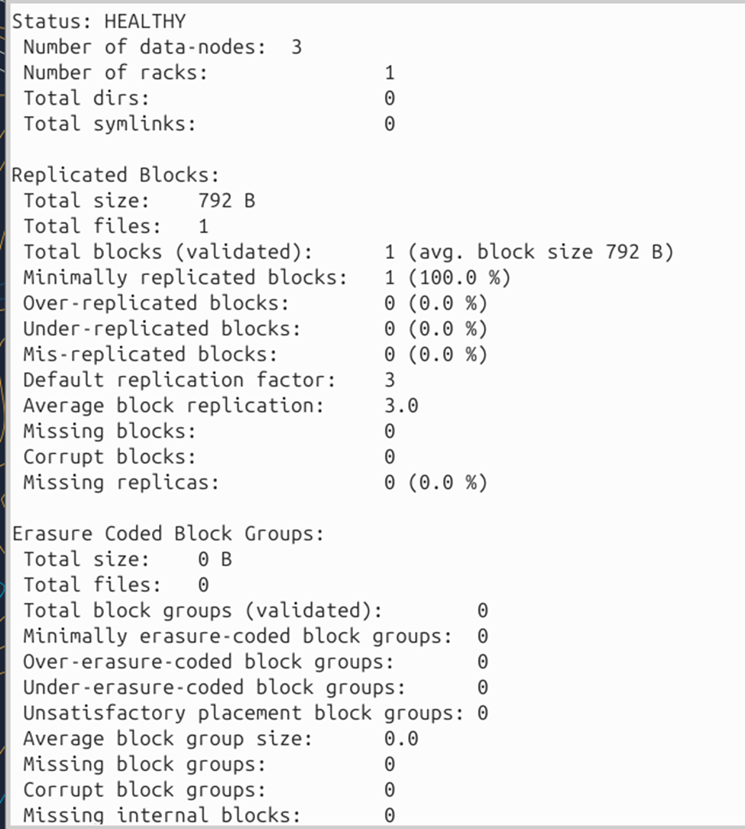

THEN MEDIUM

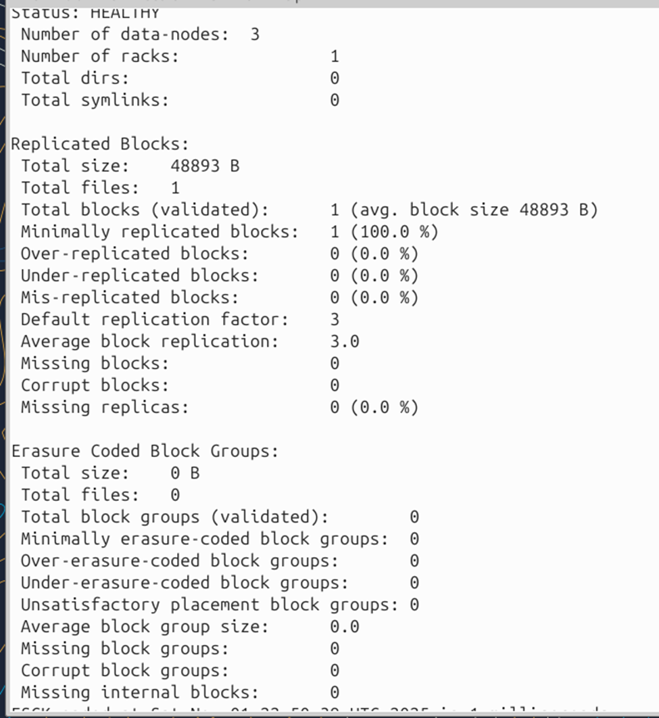

THEN LARGE

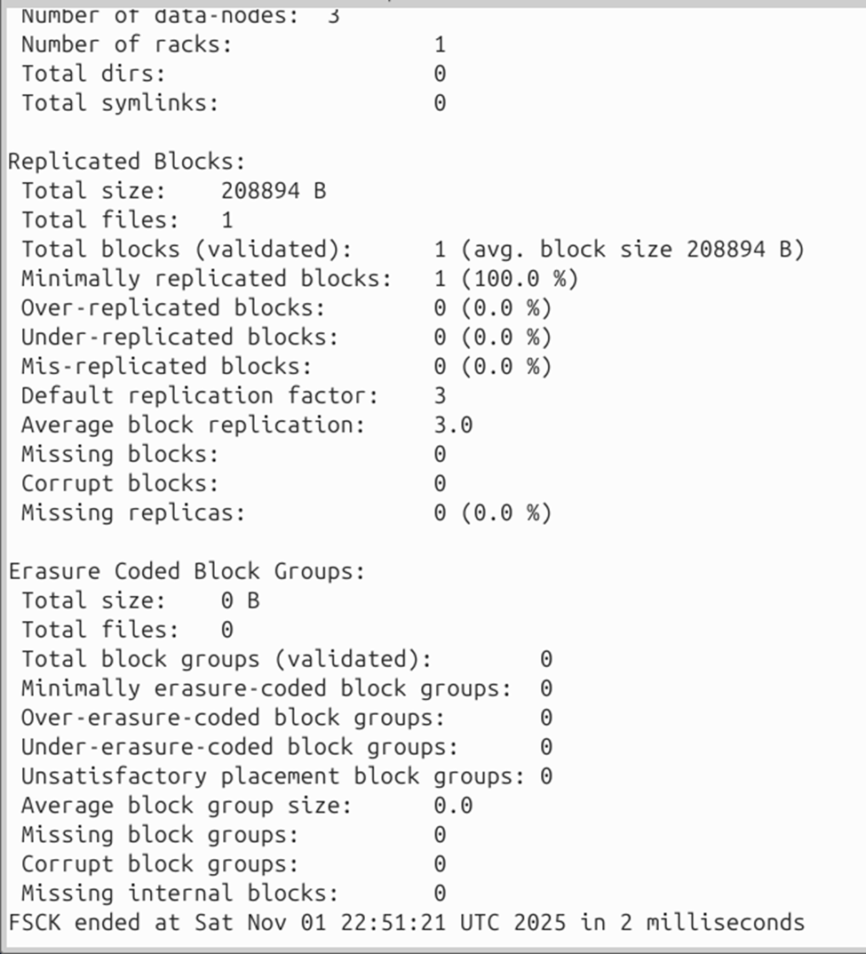

OBSERVATION: EACH FILE IS 1 BLOCK BECAUSE ALL FILES ARE <128MB

#### Exercise 5: Inter-Cluster Data Replication with DistCp

**Task**: Copy your dataset from Cluster 1 to Cluster 2 using DistCp.

**What to do**:

1. Use DistCp to copy /user/yourname/ from Cluster 1 to Cluster 2
2. Verify the data exists in Cluster 2 by listing the directory
3. Compare file sizes and checksums between clusters
4. Read a file from Cluster 2 to confirm data integrity

**Task**: Screenshot of the DistCp command execution and its output

**Task**: Screenshot of file listings from both clusters side-by-side proving successful replication (**Hint**: DistCp syntax: hadoop distcp hdfs://namenode-c1:8020/source hdfs://namenode-c2:8020/destination)

**Copied**

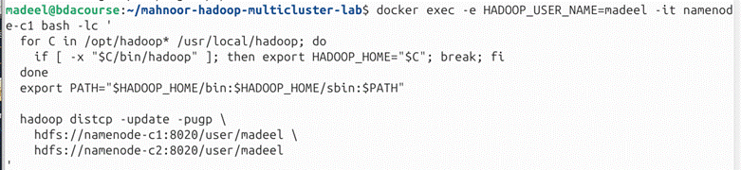

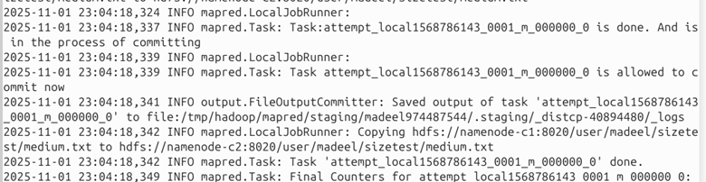

**Now listing directory**

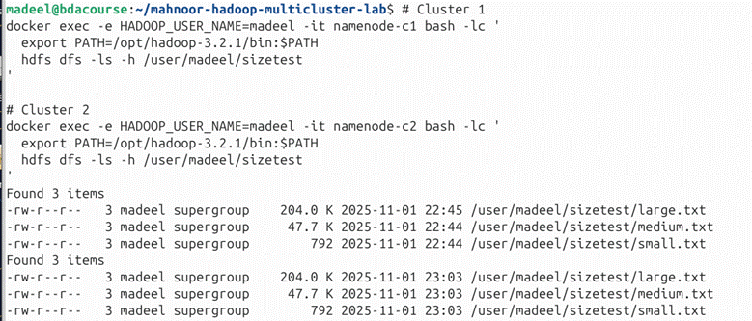

**Now compare filesize plus checksum**

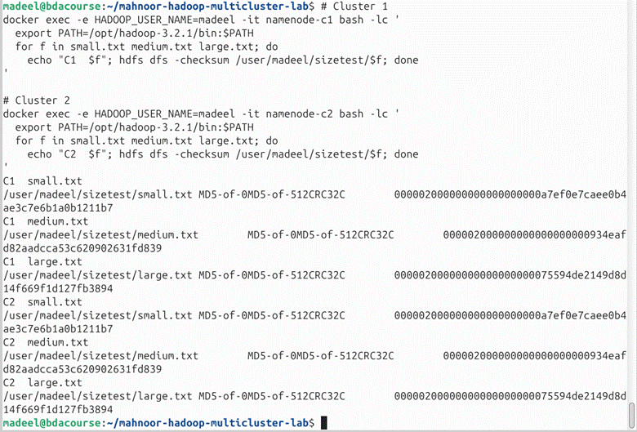

**Then listed contents**

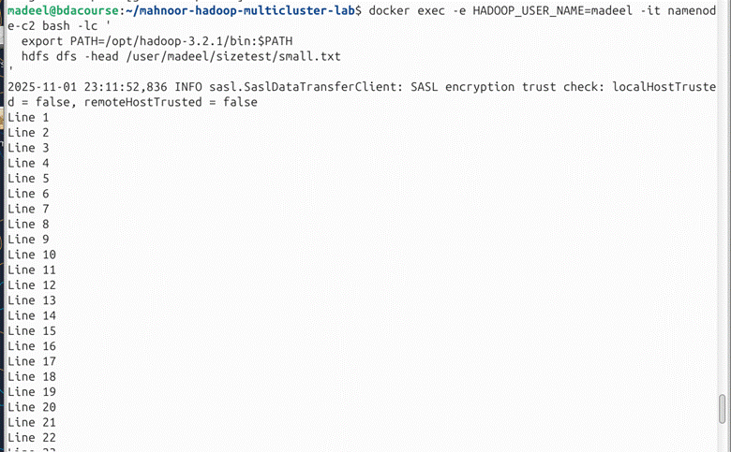

#### Exercise 6: Create Directory Structure and Organize Files

**Task**: Create a proper directory hierarchy and organize files in Cluster 2.

**What to do**:

1. In Cluster 2, create a directory structure: /production/data/year2024/month09/
2. Move your replicated files into this organized structure
3. Create a separate /backup/ directory
4. Copy (not move) one file to the backup location

**Task**: Screenshot of your complete directory tree structure using recursive listing

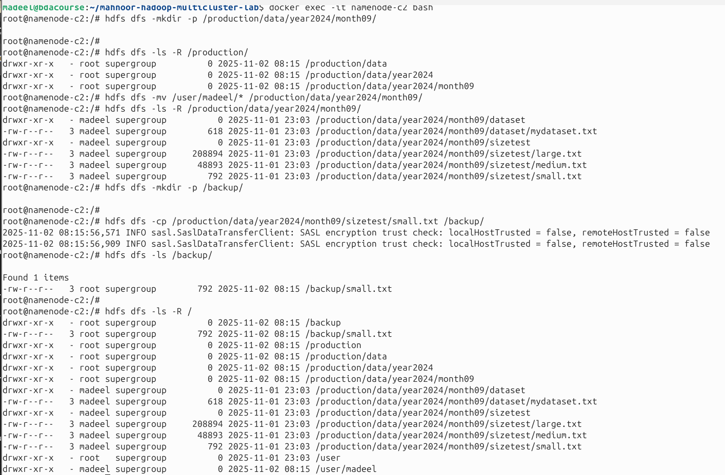

**(Hint**: Use hdfs dfs -mkdir -p for nested directories and hdfs dfs -mv and hdfs dfs -cp)

#### Exercise 7: Test NodeManager Failure and YARN Recovery

**Task**: Simulate a NodeManager failure and observe YARN's response.

**What to do**:

1. Check all NodeManagers are running in Cluster 1
2. Stop nodemanager1-c1 container
3. Check YARN node status - how many are active now?
4. Try submitting a simple test job (calculate π using the example jar)
5. Observe: Does the job run with only one NodeManager?
6. Restart the NodeManager

**Task**: Screenshot of YARN node list before and after NodeManager failure

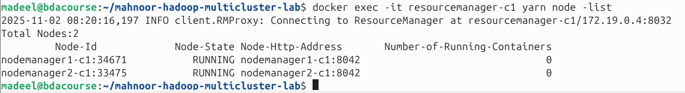

**Task**: Screenshot of a successfully completed job running with reduced resources

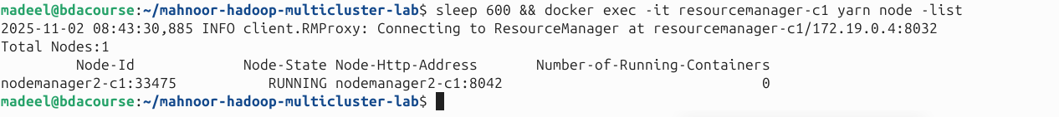

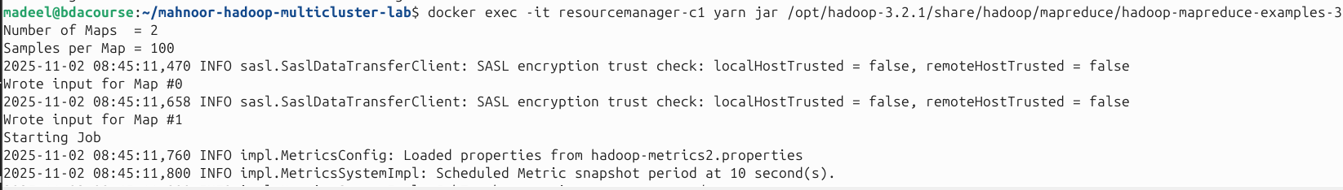

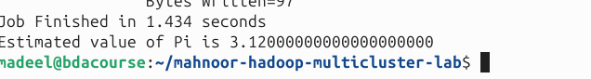

When nodemanager1-c1 was stopped, YARN automatically marked the node as lost but continued to run jobs using the rnodemanager2-c1. The π calculation job completed successfully despite reduced resources, demonstrating YARN’s fault tolerance.

**Restarted** nodemanager1-c1**:**

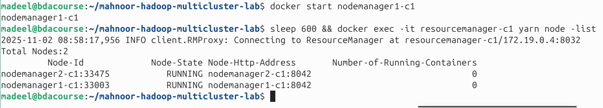

**(Hint**: Use yarn node -list and the example: yarn jar /opt/hadoop-3.2.1/share/hadoop/mapreduce/hadoop-mapreduce-examples-3.2.1.jar pi 2 100)

#### Exercise 8: Change File Replication Factor

**Task**: Modify the replication factor of specific files and observe the effect.

**What to do**:

1. Check current replication of one of your files (should be 3)
2. Change replication factor to 2
3. Wait and verify the change took effect
4. Change it to 1, then back to 3
5. Observe in UI: Watch blocks being added/removed from DataNodes

**Task**: Screenshot of setrep command and before/after status of the file

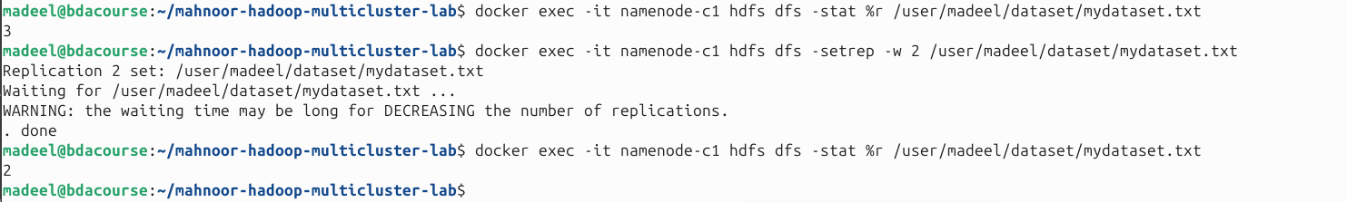

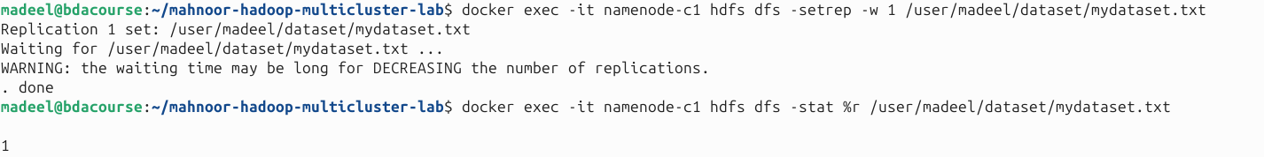



**Task**: Screenshot of NameNode UI displaying the file's current replication status

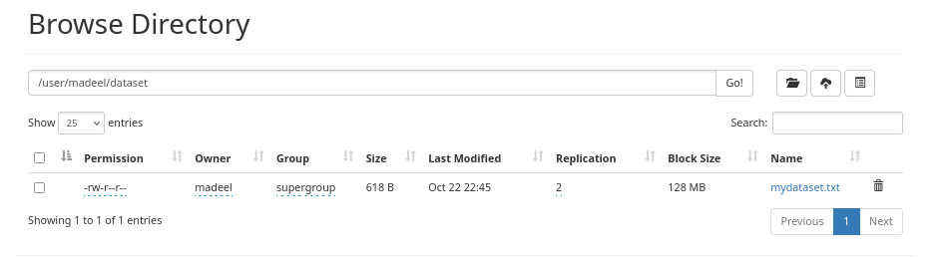

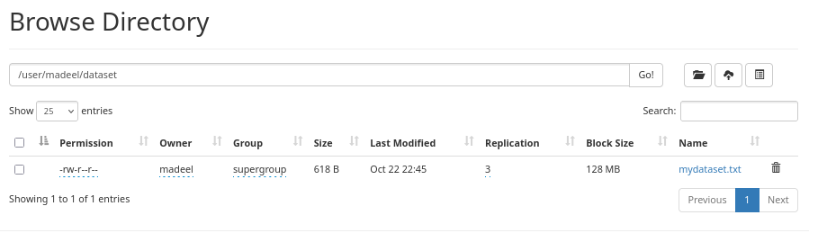

**Hint**: Use hdfs dfs -setrep -w 2 /path/to/file (the -w flag waits for replication to complete)

#### Exercise 9: Create and Test HDFS Snapshots

**Task**: Create snapshots to preserve data state and test restoration.

**What to do**:

1. Enable snapshots on your data directory
2. Create a snapshot named "backup_v1"
3. Modify or delete one of your files
4. List available snapshots
5. Restore the deleted/modified file from the snapshot
6. Verify the restoration was successful

**Task**: Screenshot of creation and the snapshot directory listing





**File Deleted:**





**Task**: Screenshot of successful file restoration from snapshot

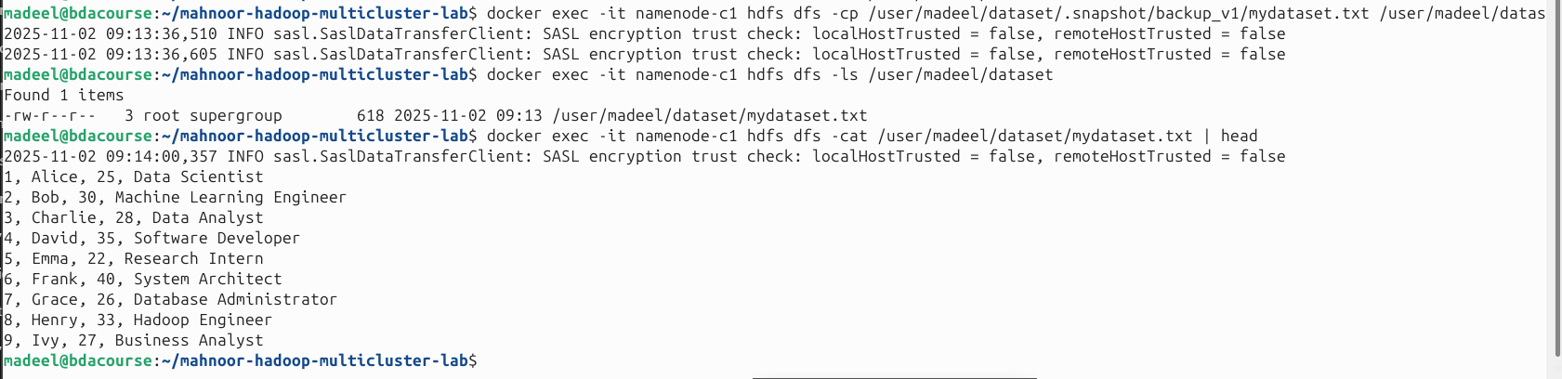

**Hint**: Use hdfs dfsadmin -allowSnapshot, hdfs dfs -createSnapshot, and restore by copying from .snapshot directory

#### Exercise 10: Run HDFS Balancer

**Task**: Check data distribution and run the balancer to even it out.

**What to do**:

1. Check current storage distribution across all DataNodes
2. Note which DataNode has the most/least data
3. Run the HDFS balancer with 10% threshold
4. Monitor the balancer progress
5. After completion, check distribution again

Task: Screenshot of DataNode storage distribution before balancing

**(Already balanced)**

The data distribution across DataNodes was already quite balanced, with storage usage around 312 KB, 312 KB, and 320 KB respectively.

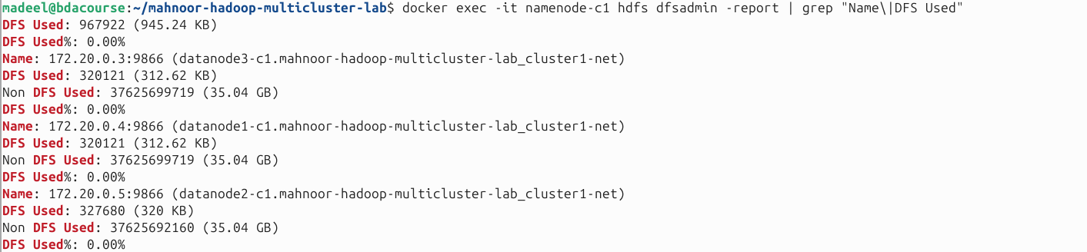

Task: Screenshot of balancer execution output and final distribution

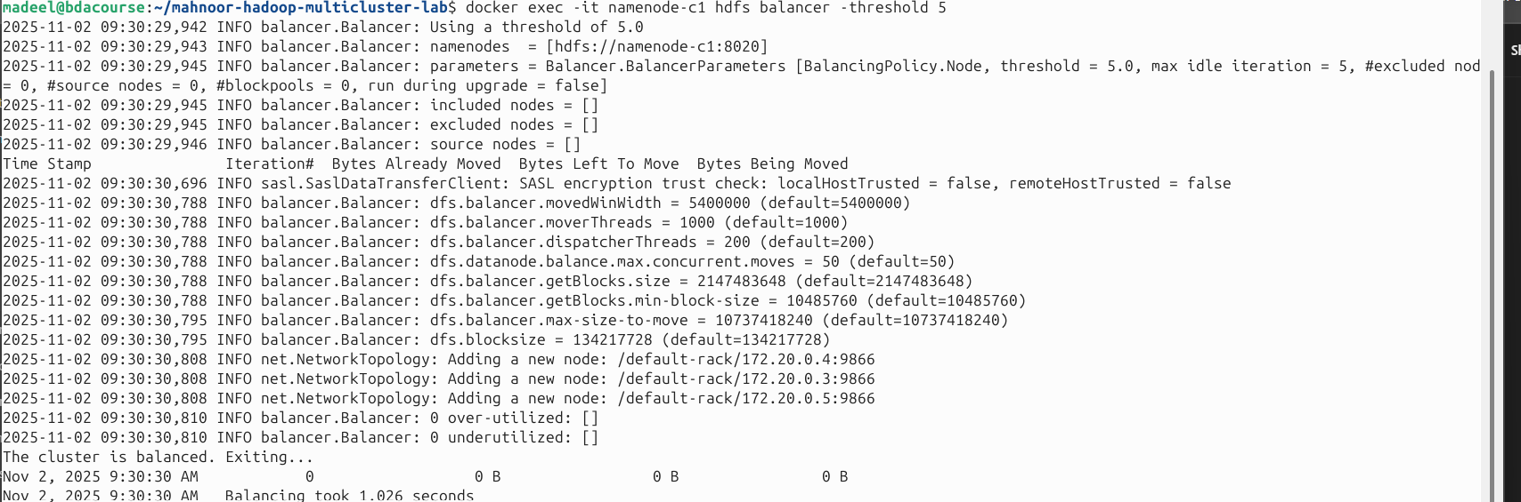

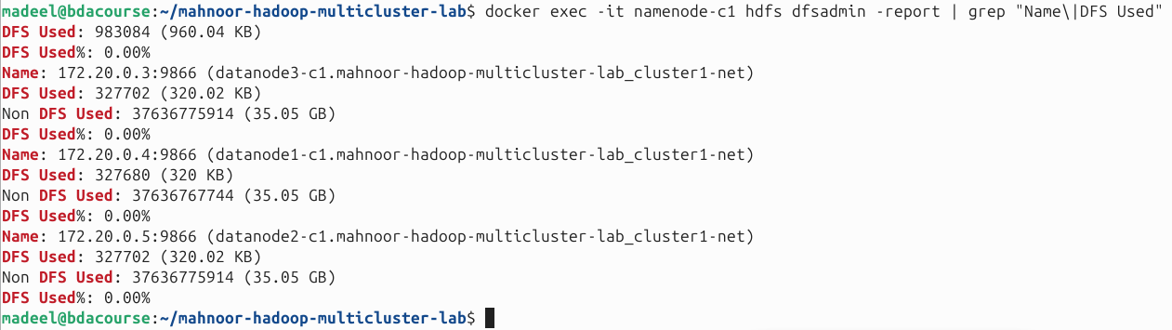**Hint**: Use hdfs dfsadmin -report | grep "DFS Used" and hdfs balancer -threshold 10

#### Exercise 11: Monitor and Compare Both Clusters

**Task**: Generate a comprehensive status report for both clusters.

**What to do**:

1. For both Cluster 1 and Cluster 2, collect:
   * Total number of files and directories
   * Total storage used
   * Number of live DataNodes
   * Number of active NodeManagers
   * Available vs. used YARN memory
2. Create a comparison document showing these metrics side-by-side

**Task:** Screenshot of command outputs collecting metrics from both clusters

**Task:** Screenshot of your completed comparison report (can be a text file, spreadsheet, or document)

**Hint**: Use hdfs dfs -count -q /, hdfs dfsadmin -report, and yarn node -lis

RUN EACH CLUSTER





NOW SHOW OUTPUT RESULT

CLUSTER1

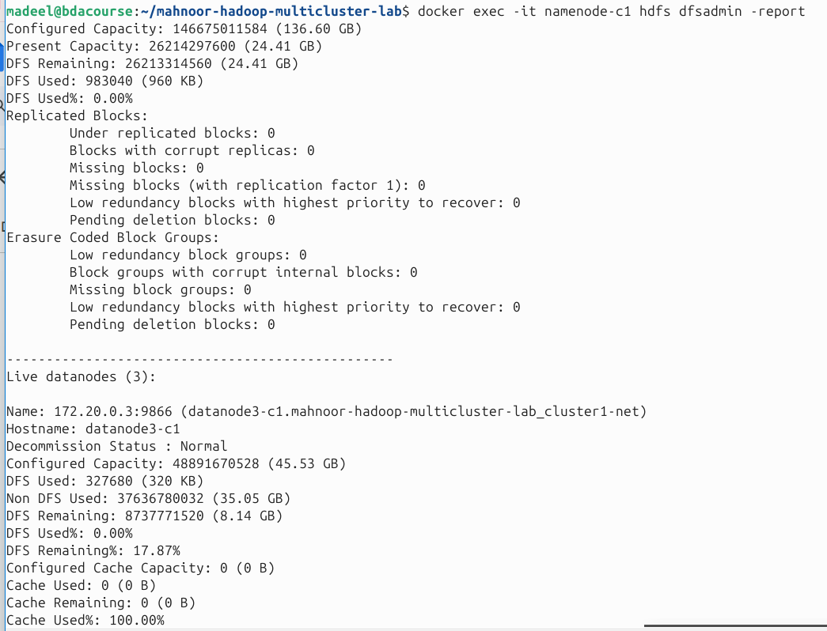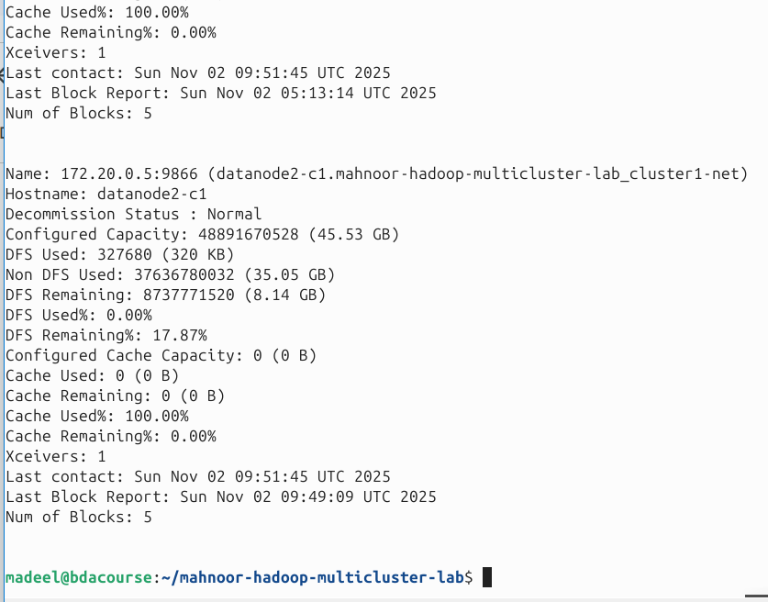

CLUSTER 2

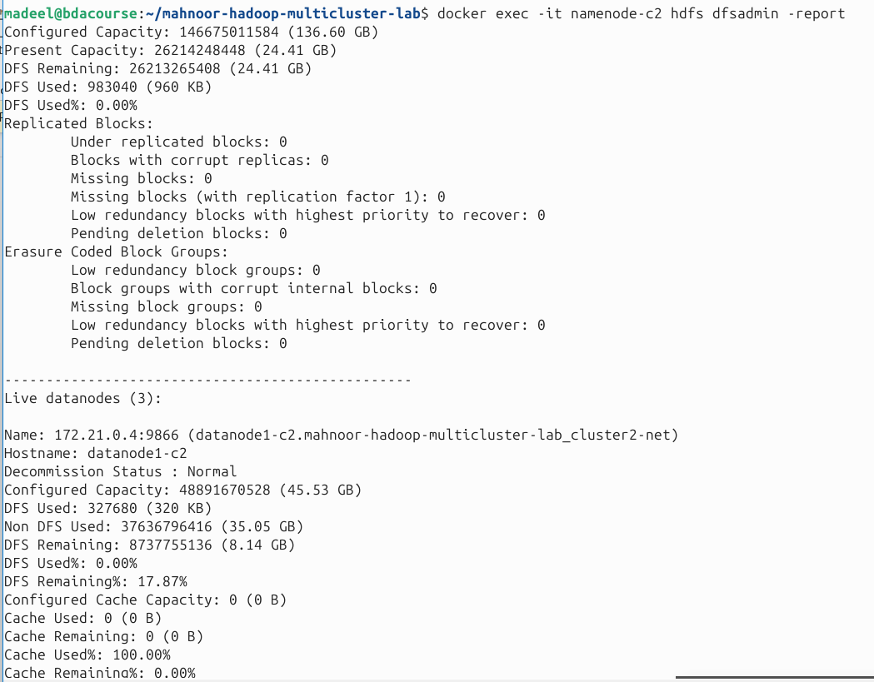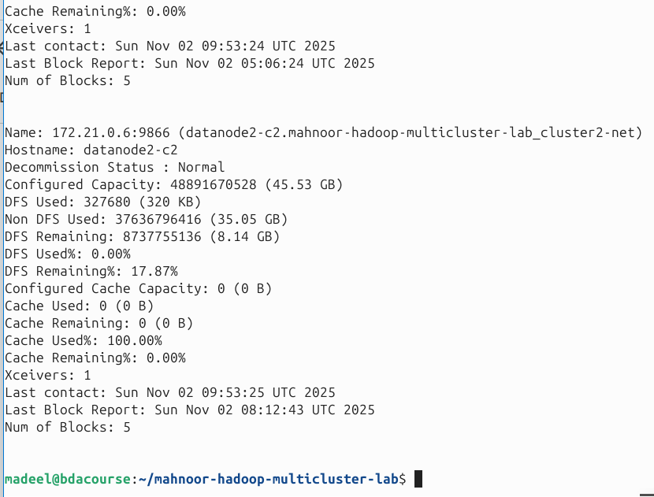

FOR YARN MANAGERS

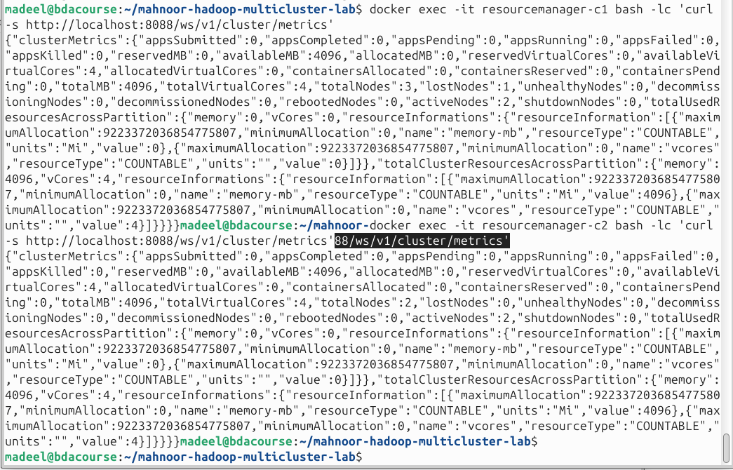

CLUSTER1

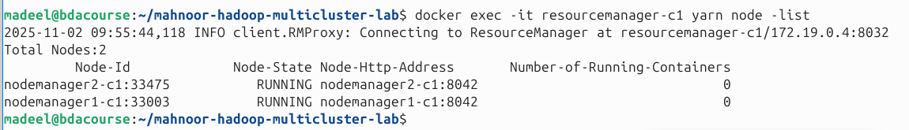

CLUSTER 2

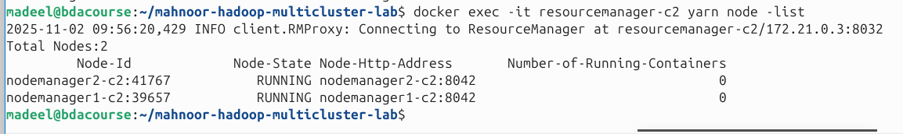

COMPARISION TABLE

| **Metric** | **Cluster 1 (C1)** | **Cluster 2 (C2)** |
| --- | --- | --- |
| **HDFS Configured Capacity (Total)** | 136.60 GB | 136.60 GB |
| **Present Capacity (post-overheads)** | 24.41 GB (26,214,297,600 B) | 24.41 GB (26,214,248,448 B) |
| **DFS Remaining** | 24.41 GB (26,213,314,560 B) | 24.41 GB (26,213,265,408 B) |
| **DFS Used** | 960 KB (983,040 B) | 960 KB (983,040 B) |
| **DFS Used %** | 0.00% | 0.00% |
| **Live DataNodes** | **3** | **3** |
| **Active YARN NodeManagers** | **2** (RUNNING) | **2** (RUNNING) |
| **Running Containers (YARN)** | 0 | 0 |
| **YARN allocatedMB** | **0** | **0** |
| **YARN availableMB** | **4096** | **4096** |
| **YARN totalMB** | **4096** | **4096** |

| **Cluster** | **DataNode** | **Configured Capacity** | **DFS Used** | **Non-DFS Used** | **DFS Remaining** | **Num of Blocks** | **Last contact (UTC)** |
| --- | --- | --- | --- | --- | --- | --- | --- |
| C1 | datanode3-c1 | 45.53 GB | 320 KB | 35.05 GB | 8.14 GB | 5 | Sun Nov 02 09:51:43 2025 |
| C1 | datanode1-c1 | 45.53 GB | 320 KB | 35.05 GB | 8.14 GB | 5 | Sun Nov 02 09:51:45 2025 |
| C1 | datanode2-c1 | 45.53 GB | 320 KB | 35.05 GB | 8.14 GB | 5 | Sun Nov 02 09:51:45 2025 |
| C2 | datanode1-c2 | 45.53 GB | 320 KB | 35.05 GB | 8.14 GB | 5 | Sun Nov 02 09:53:25 2025 |
| C2 | datanode3-c2 | 45.53 GB | 320 KB | 35.05 GB | 8.14 GB | 5 | Sun Nov 02 09:53:24 2025 |
| C2 | datanode2-c2 | 45.53 GB | 320 KB | 35.05 GB | 8.14 GB | 5 | Sun Nov 02 09:53:25 2025 |

#### Exercise 12: Cross-Cluster Data Movement Challenge

**Task**: Create a workflow that synchronizes specific data between clusters.

**What to do**:

1. Create a new file in Cluster 1 under /user/yourname/updates/
2. Use DistCp to sync only new/changed files to Cluster 2
3. Verify only the new file was copied
4. Modify a file in Cluster 1
5. Re-run sync and verify the update propagated

**Task:** Screenshot the DistCp sync operation and verification of selective copying

**Hint**: Use DistCp with -update flag for incremental sync

**GO INSIDE NAMENODE EACH CLUSTER IN SEPERATE TERMINALS**

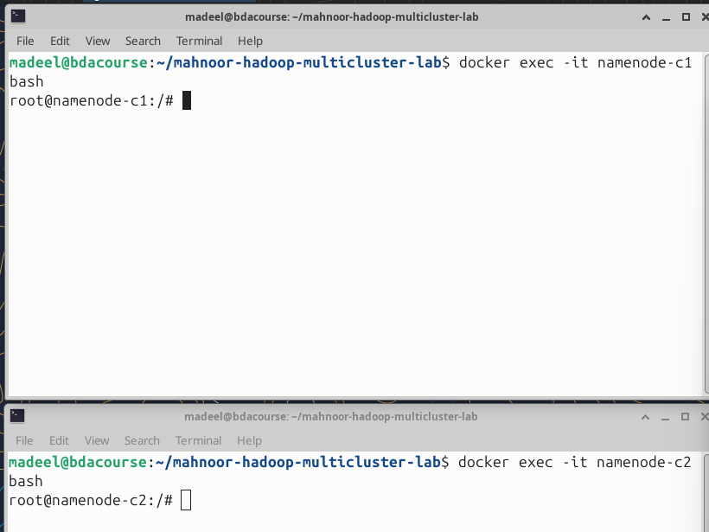

**Create a folder**



**And create a file and upload to hdfs**

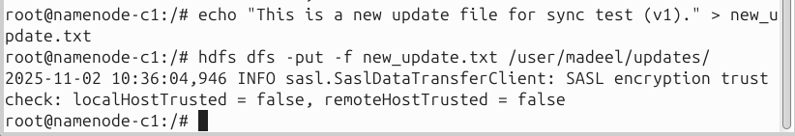

**And verify it is in hdfs**

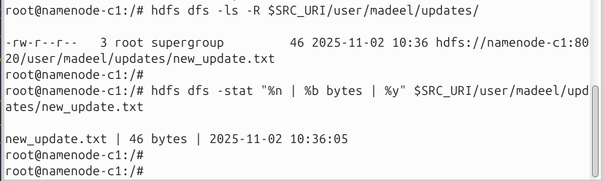

**Use distcp**

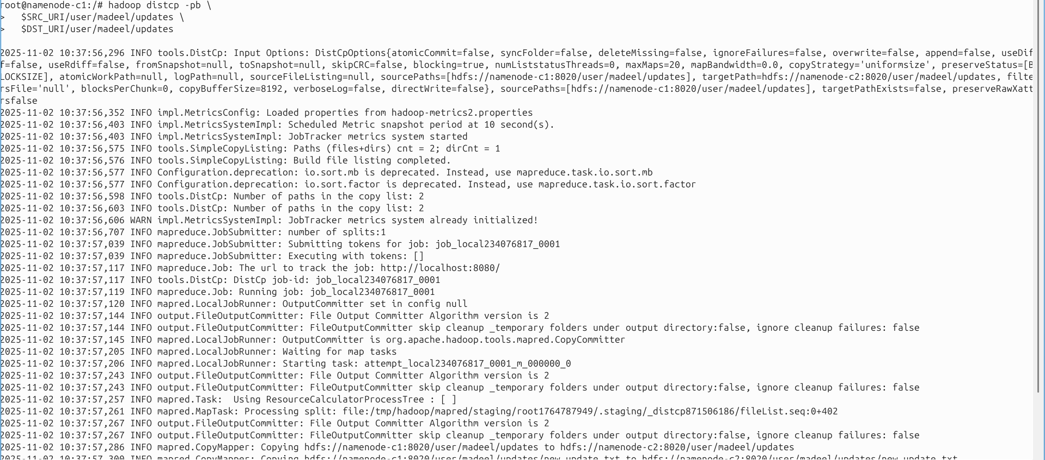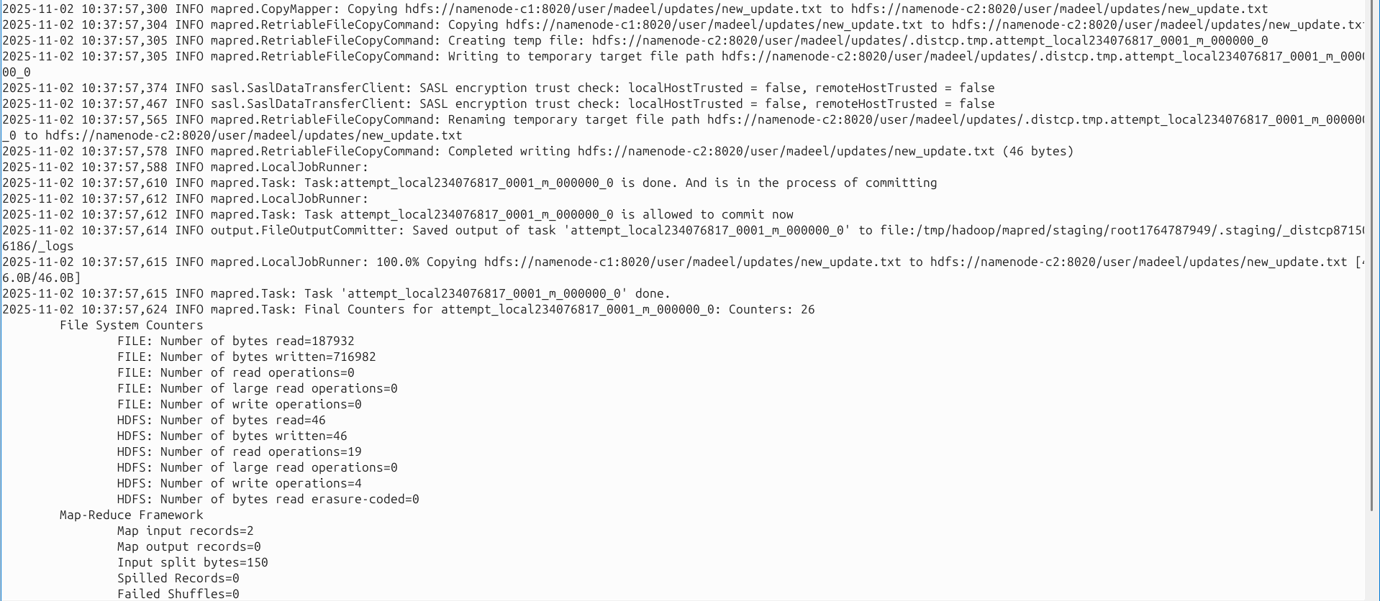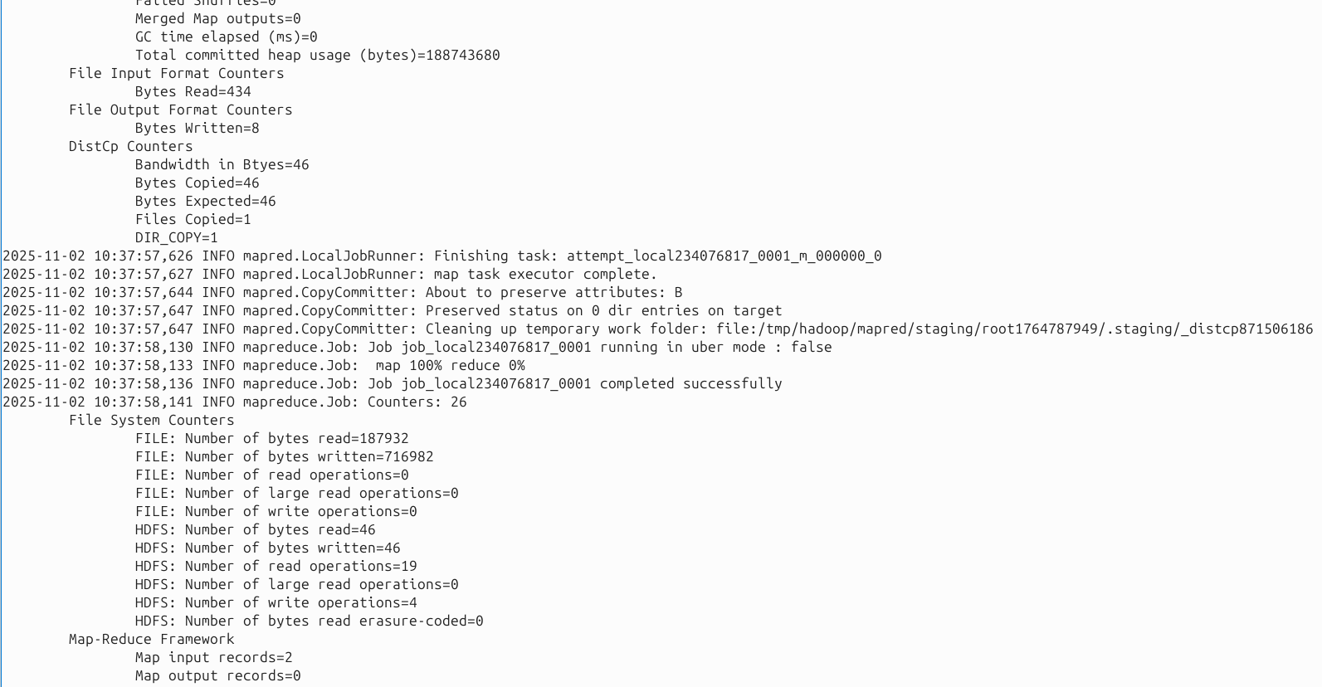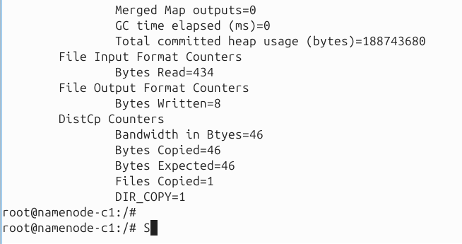

**NOW VERIFY ON CLUSTER2**

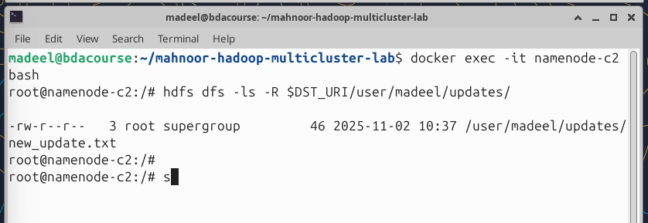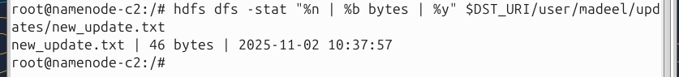

**NOW LETS ONLY SYNC ONE FILE**

**ON CLUSTER 1, LETS ADD A SECOND FILE**

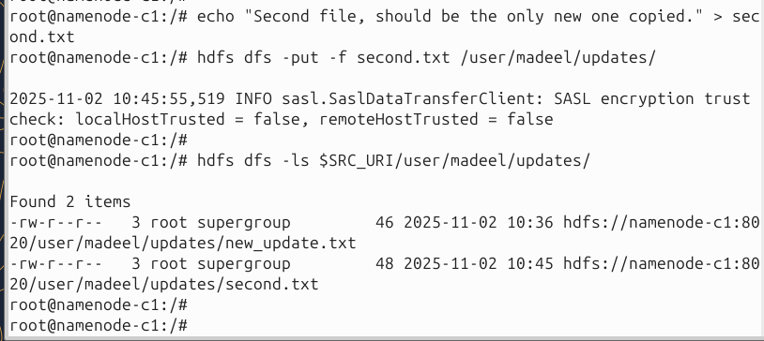

**AND ON CLUSTER 2 LETS ONLY SYNC THIS SECOND FILE**

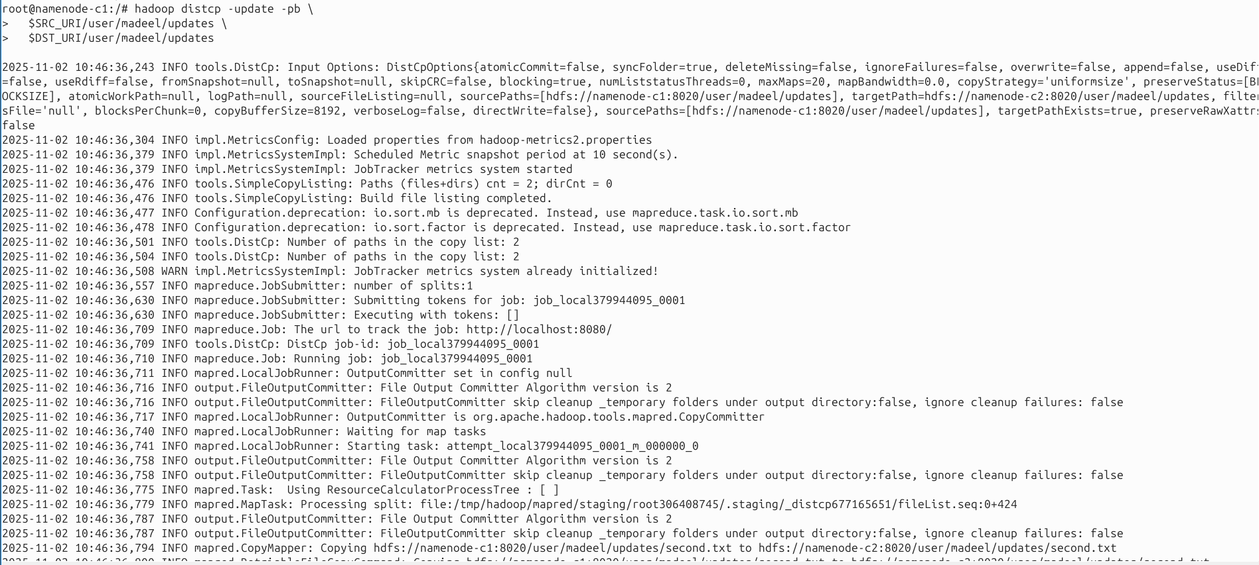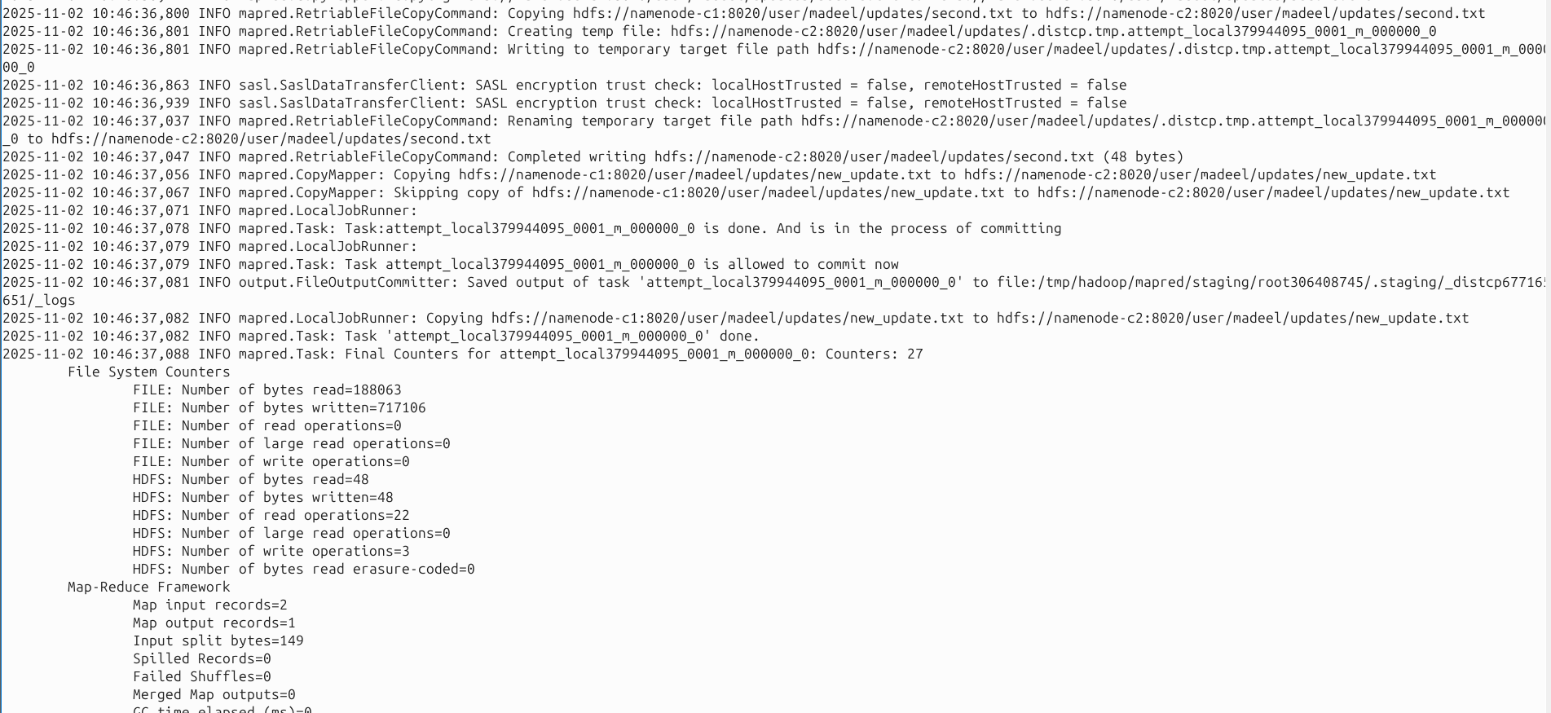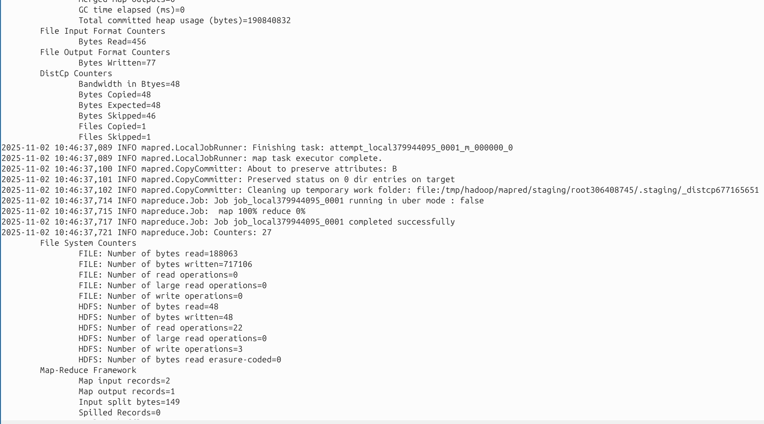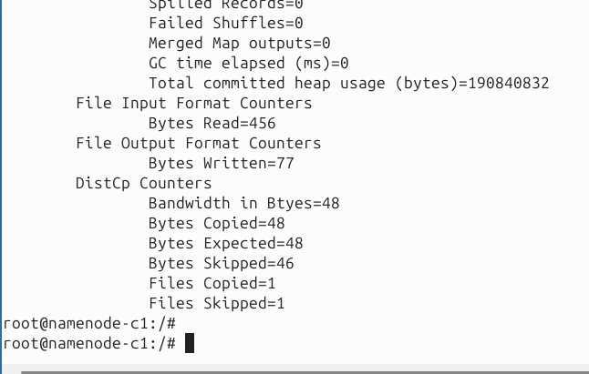

**NOW LETS VERIFY ON CLUSTER2**

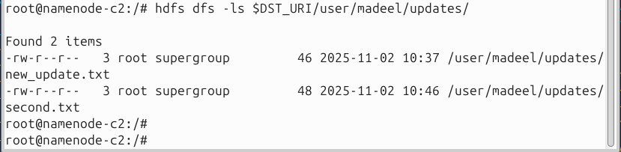

**RECEIVED. NOW LETS EDIT A FILE ON C1 AND RESYNC**

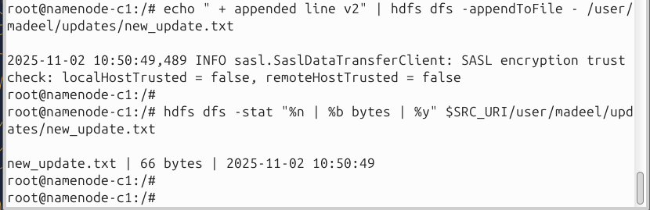

**NOW LETS DO DISTCP**

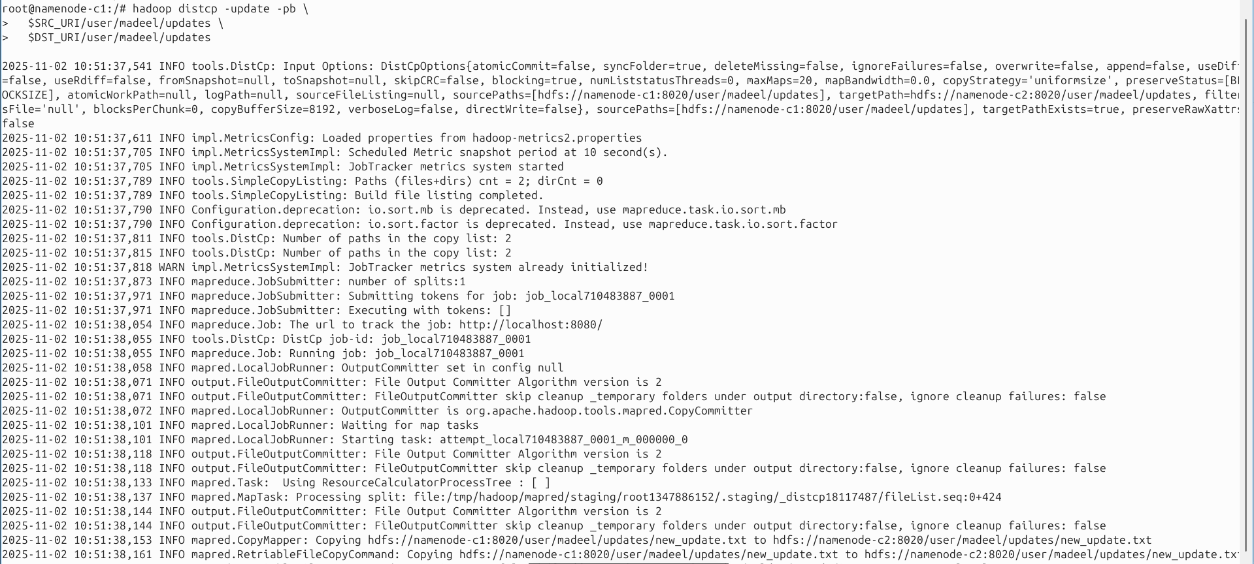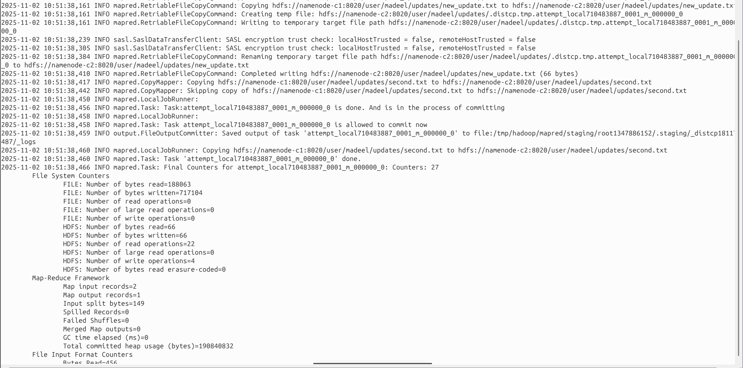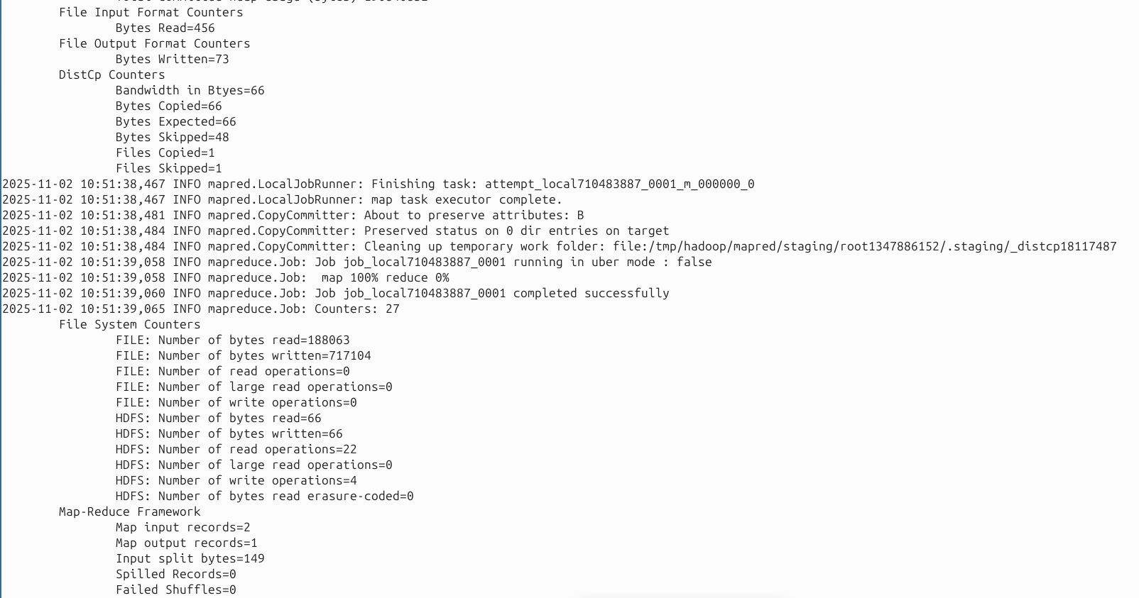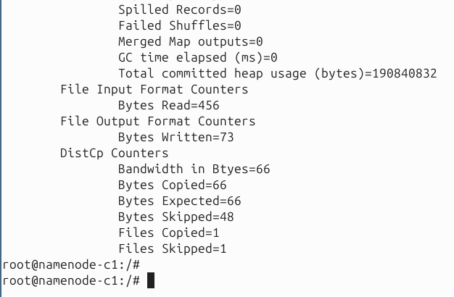

**NOW LETS VERIFY**

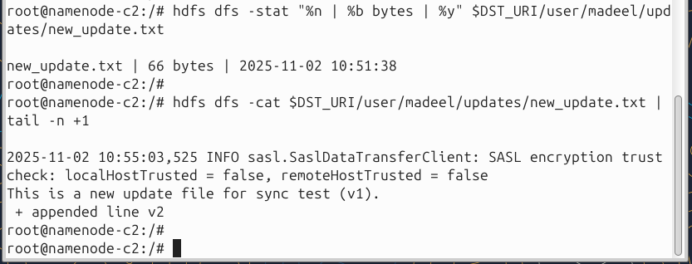

**RECEIVED UPDATED**

#### **Highest Weightage.**

#### Exercise 13: MapReduce on multi-cluster and single-cluster

**Task:** Run a MR task on the multi-cluster and the single-cluster environment. Compare the performance using any of the information above and other (eg timing consumed in each task). Use the dashboards’ data to support your answer if you want. You can paste as many snapshots as you want.

So using the same data as TASK 4



Single Cluster:



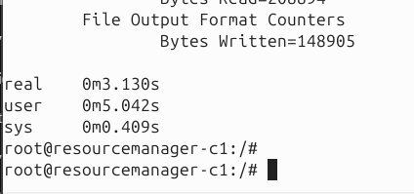

Multi-Cluster-Time = 3.13

Multi cluster: splitted the data of large.txt

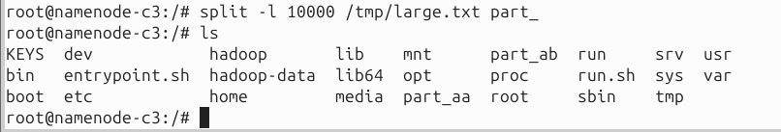

Then uploaded the data to each cluster

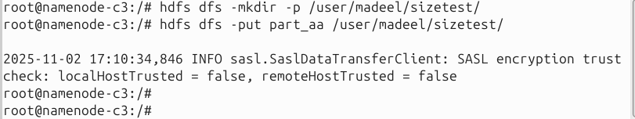

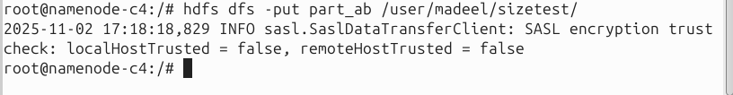

Now we run wordcount on parallel on each namenode cluster

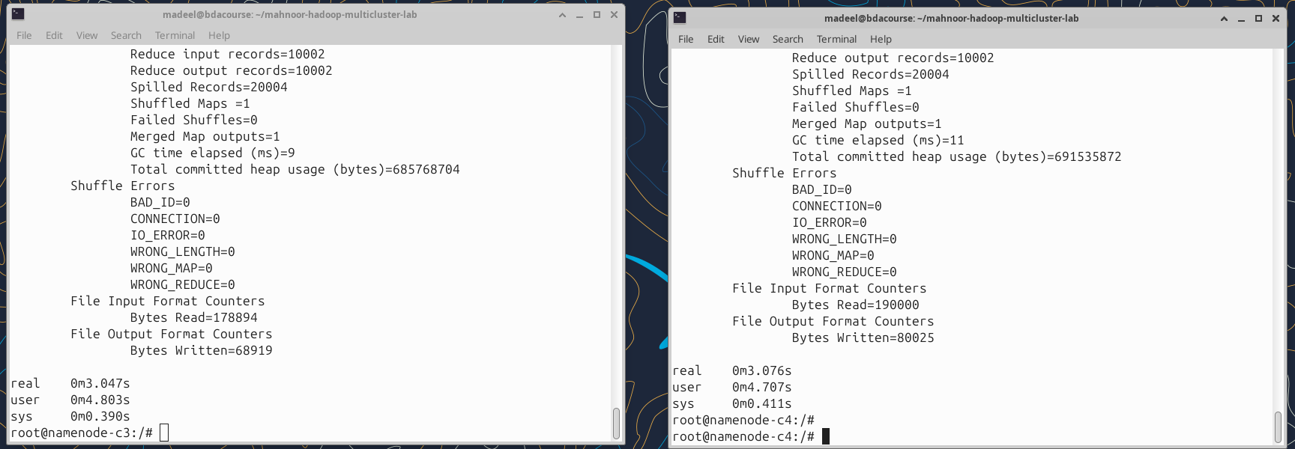

Now we will copy the cluster 4 output to cluster 3 using distcp

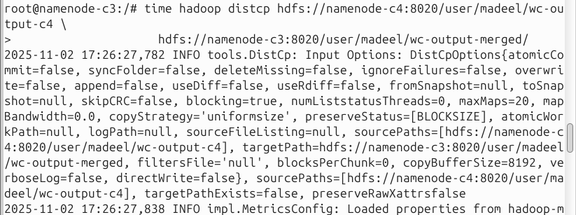

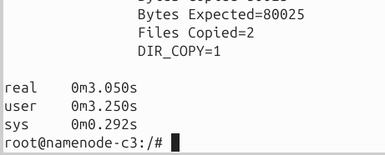

Now we merge the two outputs together

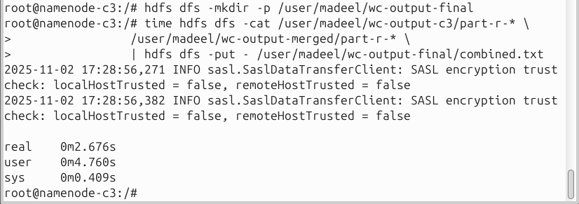

Now we verify that one output file has been made

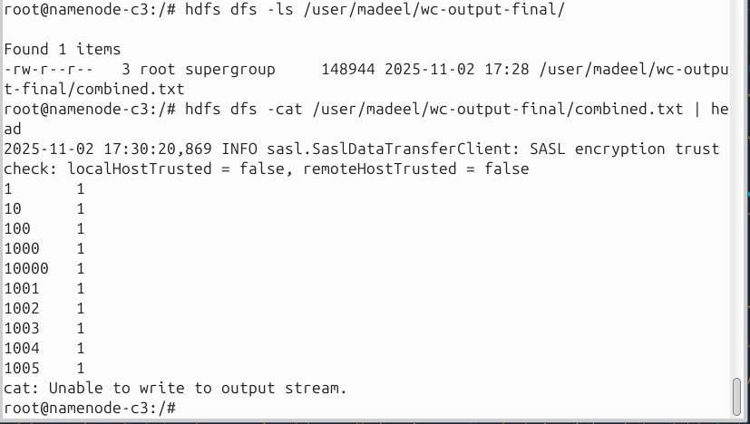

Done.

The total multi-cluster time is the time taken by the slower of the two parallel jobs plus the time to copy Cluster 4’s output to Cluster 3 (DistCp) and merge the results. This accounts for parallel execution and the overhead of combining outputs into a single final dataset.

Multi-Cluster-Time = max(T_cluster3_job, T_cluster4_job) + T_DistCp + T_merge

Multi-Cluster-Time = max(3.047, 3.076) + 3.050 + 2.676

Multi-Cluster-Time = 8.802

For this experiment, the single-cluster job completed in about 3 seconds, while the multi-cluster setup took longer (~8 seconds) even though each cluster processed only half the data. This is because the dataset was small (around 20,000 lines), so the Map tasks themselves were quick, but the multi-cluster workflow incurred overhead: 3 seconds for running the Map tasks, 3 seconds to copy the output from one cluster to the other using DistCp, and 2 seconds for merging the results. This demonstrates that for small datasets, the coordination and merge overhead in a multi-cluster setup can outweigh the benefits of parallelism. For larger files, the Map task time per cluster would decrease because the workload is split across multiple clusters, and the merge overhead becomes proportionally smaller relative to the total processing time. This allows the system to scale efficiently, making multi-cluster setups advantageous for handling big datasets.

## Cleanup

#### Stop Both Clusters

cd ~/hadoop-multicluster-lab

# Stop Cluster 1

docker compose -f docker-compose-cluster1.yml down

# Stop Cluster 2

docker compose -f docker-compose-cluster2.yml down

# Remove shared network

docker network rm shared-net

**Show proof**

